UNITED STATES
SECURITIES AND EXCHANGE COMMISSION
WASHINGTON, D.C. 20549

FORM 8-K

CURRENT REPORT

Pursuant to Section 13 or 15(d) of the Securities Exchange Act of 1934

Date of Report (Date of earliest event reported): August 5, 2026

EMERGENT BIOSOLUTIONS INC.
(Exact name of registrant as specified in its charter)

Delaware |  |  |  |  |  | 001-33137 |  |  |  |  |  | 14-1902018
(State or other jurisdiction |  |  |  |  |  | (Commission File Number) |  |  |  |  |  | (IRS Employer
of incorporation) |  |  |  |  |  |  |  |  |  |  |  | Identification No.)
300 Professional Drive,
Gaithersburg, Maryland 20879
(Address of principal executive offices, including zip code)

(240) 631-3200
(Registrant’s telephone number, including area code)

N/A
(Former name or former address, if changed since last report)

Check the appropriate box below if the Form 8-K filing is intended to simultaneously satisfy the filing obligation of the registrant under any of the following provisions (see General Instruction A.2. below):
☐ Written communications pursuant to Rule 425 under the Securities Act (17 CFR 230.425)
☐ Soliciting material pursuant to Rule 14a-12 under the Exchange Act (17 CFR 240.14a-12)
☐ Pre-commencement communications pursuant to Rule 14d-2(b) under the Exchange Act (17 CFR 240.14d-2(b))
☐ Pre-commencement communications pursuant to Rule 13e-4(c) under the Exchange Act (17 CFR 240.13e-4(c))
Securities registered pursuant to Section 12(b) of the Act:
Title of each class |  |  | Trading Symbol(s) |  |  | Name of each exchange on which registered
Common Stock, $0.001 par value per share |  |  | EBS |  |  | New York Stock Exchange
Indicate by check mark whether the registrant is an emerging growth company as defined in Rule 405 of the Securities Act of 1933 (§230.405 of this chapter) or Rule 12b-2 of the Securities Exchange Act of 1934 (§240.12b-2 of this chapter).
Emerging growth company ☐
If an emerging growth company, indicate by check mark if the registrant has elected not to use the extended transition period for complying with any new or revised financial accounting standards provided pursuant to Section 13(a) of the Exchange Act. ☐

Item 2.02. Results of Operations and Financial Condition.
On August 5, 2026, Emergent BioSolutions Inc. (the "Company") issued a press release (the "Press Release") announcing its financial and operating results for the quarter ended June 30, 2026. A copy of the Press Release is furnished as Exhibit 99.1 to this Current Report on Form 8-K (this "Form 8-K") and is incorporated herein by reference.
Item 2.05. Costs Associated with Exit or Disposal Activities.
On August 5, 2026, the Company announced an organizational restructuring plan (the “Restructuring Plan”) intended to strengthen its long-term financial position in response to changes in its business. These strategic actions will lead to a reduction of the Company’s current workforce by approximately 93 employees across all areas of the Company and the elimination of approximately 21 positions that are currently vacant, as well as the closure of wet laboratories in Gaithersburg, Maryland. Decisions regarding the elimination of positions and the closure of wet laboratories are subject to local law and consultation requirements in certain countries, as well as the Company’s business needs. In combination with other rationalizing initiatives, these actions are expected to result in annualized savings of approximately $40 million when fully implemented.
The Company estimates that it will incur approximately $10 million to $11.5 million in charges in connection with the Restructuring Plan, which it expects to incur primarily in the second half of 2026. These charges consist primarily of cash charges related to severance (base bonus), transition services, and estimated benefits cost.
The estimates of the charges and expenditures that the Company expects to incur in connection with the Restructuring Plan, and the timing thereof, are subject to a number of assumptions, including local law requirements in various jurisdictions, and actual amounts may differ materially from estimates. In addition, the Company may incur other charges or cash expenditures not currently contemplated due to unanticipated events that may occur, including in connection with the implementation of the Restructuring Plan. Expected annualized savings attributable to the Restructuring Plan are also subject to a number of assumptions, and actual amounts may differ materially from estimates.
Item 5.02. Departure of Directors or Certain Officers; Election of Directors; Appointment of Certain Officers; Compensatory Arrangements of Certain Officers.
In connection with the actions described above, on August 5, 2026 the Company also announced that it will eliminate the role of Chief Medical Officer, Head of Research and Development. As such, Simon Lowry, the Company’s Chief Medical Officer, Head of Research and Development will be leaving the Company effective August 19, 2026. The Company also announced that Stephanie Duatschek, Senior Vice President, Chief Global Strategy & Franchise Development Officer, will assume the role of Executive Vice President, Chief Growth Officer, with responsibility for the Company’s strategic growth. Ms. Duatschek will continue reporting to the Company’s Chief Executive Officer, Joseph Papa.
Item 7.01. Regulation FD Disclosure.
On August 5, 2026, the Company will host a conference call to discuss its financial and operating results for the quarter ended June 30, 2026. The Company will use presentation materials in connection with this conference call (the "Earnings Call Slides"), which will be posted on the Company’s website at www.emergentbiosolutions.com. A copy of the Earnings Call Slides is furnished as Exhibit 99.2 to this Form 8-K and is incorporated herein by reference. Information on the Company's website is not, and will not be deemed to be, a part of this Form 8-K or incorporated into any other filings the Company may make with the U.S. Securities and Exchange Commission.
The information contained in Items 2.02 and 7.01 of this Form 8-K and Exhibits 99.1 and 99.2 attached hereto, shall not be deemed "filed" for purposes of Section 18 of the Securities Exchange Act of 1934, as amended (the "Exchange Act"), or otherwise be subject to the liabilities of that section, nor shall it be deemed incorporated by reference in any filing under the Securities Act of 1933, as amended, or the Exchange Act, except as expressly set forth by specific reference in such filing.
Safe Harbor Statement
This Form 8-K includes forward-looking statements within the meaning of the Private Securities Litigation Reform Act of 1995. All statements, other than statements of historical fact, including statements regarding the expected timing for implementation of the Restructuring Plan, its total and cash cost, and our ability to achieve the objectives of the Restructuring Plan, including our future results and expected annualized savings, are forward-looking statements. The Company generally identifies forward-looking statements by using words like “anticipate,” “believe,” “can,” “commit,” “confident,” “continue,” “could,” “estimate,” “expect,” “forecast,” “future,” “goal,” “intend,” “may,” “outlook,” “plan,” “position,” “possible,” “potential,” “predict,” “project,” “should,” “target,” “will,” “would,” and similar expressions or variations thereof, or the negative thereof, but these terms are not the exclusive means of identifying such statements. Forward-looking statements are based on the Company’s

current intentions, beliefs and expectations regarding future events based on information that is currently available. Readers should realize that if underlying assumptions prove inaccurate or if known or unknown risks or uncertainties materialize, actual results could differ materially from the Company’s expectations. Readers are, therefore, cautioned not to place undue reliance on any forward-looking statement. Any forward-looking statement speaks only as of the date of this Form 8-K, and, except as required by law, the Company does not undertake any obligation to update any forward-looking statement to reflect new information, events or circumstances.
Item 9.01. Financial Statements and Exhibits.
(d) Exhibits.
Exhibit No. |  |  |  |  |  | Description
99.1 |  |  |  |  |  | Press release issued by Emergent BioSolutions Inc. on August 5, 2026.
99.2 |  |  |  |  |  | Earnings Call Slides, dated August 5, 2026.
104 |  |  |  |  |  | Cover Page Interactive Data File (embedded within the Inline XBRL document).

SIGNATURE

Pursuant to the requirements of the Securities Exchange Act of 1934, the registrant has duly caused this report to be signed on its behalf by the undersigned hereunto duly authorized.

 |  |  | EMERGENT BIOSOLUTIONS INC.
Dated: August 5, 2026 |  |  | By: |  |  | /s/ RICHARD S. LINDAHL
Name: Richard S. Lindahl
Title: Executive Vice President, Chief Financial
Officer

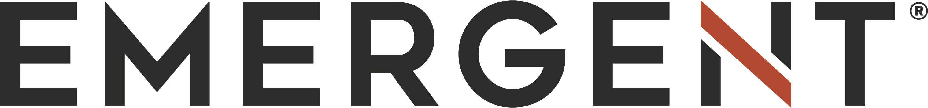
EMERGENT BIOSOLUTIONS REPORTS SECOND QUARTER 2026 FINANCIAL RESULTS
•Second Quarter 2026 Total Revenues of $234.3 million, an improvement of 66% versus prior year
•Second Quarter 2026 Net Loss of $180.2 million worsening 1,402% versus prior year, largely due to a $191.3 million non-cash impairment charge
•Second Quarter 2026 Adjusted Net Income of $30.9 million improved 134% versus prior year
•Second Quarter 2026 Gross Margin % of 50% and Adjusted Gross Margin % of 58%, an expansion of 1400 bps and 900 bps, respectively, versus prior year
•Second Quarter 2026 Adjusted EBITDA of $96.5 million and Adjusted EBITDA Margin of 41%, an improvement of 1,800 bps versus prior year
•Restructuring business operations to align resourcing to current needs; expected to result in annualized savings of approximately $40 million when fully implemented

GAITHERSBURG, Md., August 5, 2026—Emergent BioSolutions Inc. (NYSE: EBS) today reported financial results for the second quarter ended June 30, 2026.
“Emergent delivered a strong second quarter, significantly exceeding the high end of our guidance range with revenues of $234 million, primarily driven by accelerated MCM/biodefense contract modifications secured with the U.S. government. This performance reflects the focus, discipline and commitment of our teams, and it reinforces the strength of our mission, our portfolio and the steadiness of our multi-year plan toward transformation," said Joe Papa, CEO of Emergent. "However, alongside of these strong results, we are at a critical juncture in our turnaround and transformation, primarily stemming from our naloxone business. Today we are implementing an organizational restructuring plan and taking proactive steps to strengthen our financial foundation, align the company to the realities of the naloxone business and preserve our ability to invest in the areas that matter most for Emergent’s future. Additionally, we seek to collaborate with AI partners for bioterrorism preparedness.”
FINANCIAL HIGHLIGHTS (1)
Q2 2026 vs. Q2 2025
($ in millions, except per share amounts) |  |  | Q2 2026 |  |  | Q2 2025 |  |  | % Change
Total Revenues |  |  | $ | 234.3 |  | $ | 140.9 |  | 66 |  | %
Net Loss |  |  | $ | (180.2) |  | $ | (12.0) |  | (1,402) |  | %
Net Loss per Diluted Share |  |  | $ | (3.49) |  | $ | (0.22) |  | (1,486) |  | %
Adjusted Net Income (2) |  |  | $ | 30.9 |  | $ | 13.2 |  | 134 |  | %
Adjusted Net Income per Diluted Share (2) |  |  | $ | 0.60 |  | $ | 0.24 |  | 150 |  | %
Adjusted EBITDA (2) |  |  | $ | 96.5 |  | $ | 33.1 |  | 192 |  | %
Net Loss Margin |  |  | (77) |  | % | (9) |  | %
Adjusted EBITDA Margin (2) |  |  | 41 |  | % | 23 |  | %
Gross Margin % |  |  | 50 |  | % | 36 |  | %
Adjusted Gross Margin % (2) |  |  | 58 |  | % | 49 |  | %
1
Year to Date ("YTD") 2026 vs YTD 2025
($ in millions, except per share amounts) |  |  | YTD 2026 |  |  | YTD 2025 |  |  | % Change
Total Revenues |  |  | $ | 390.4 |  | $ | 363.1 |  | 8 |  | %
Net Income (Loss) |  |  | $ | (173.4) |  | $ | 56.0 |  | (410) |  | %
Net Income (Loss) per Diluted Share |  |  | $ | (3.35) |  | $ | 0.99 |  | (438) |  | %
Adjusted Net Income (2) |  |  | $ | 42.8 |  | $ | 55.4 |  | (23) |  | %
Adjusted Net Income per Diluted Share (2) |  |  | $ | 0.83 |  | $ | 0.98 |  | (15) |  | %
Adjusted EBITDA (2) |  |  | $ | 132.0 |  | $ | 112.2 |  | 18 |  | %
Net Income (Loss) Margin |  |  | (44) |  | % | 15 |  | %
Adjusted EBITDA Margin (2) |  |  | 34 |  | % | 31 |  | %
Gross Margin % |  |  | 46 |  | % | 45 |  | %
Adjusted Gross Margin % (2) |  |  | 56 |  | % | 55 |  | %

RECENT BUSINESS UPDATES
•Secured contract modification from U.S. government and completed delivery of approximately $52.7 million of ACAM2000® (Smallpox and Mpox (Vaccinia) Vaccine, Live)
•Executed $64.5 million for BAT® (Botulism Antitoxin Heptavalent (A, B, C, D, E, F, G) – (Equine)) contract modification with U.S. government
•Secured two new strategic manufacturing partnerships with:
◦SAB Biotherapeutics to advance its type 1 diabetes candidate, SAB-142
◦Substipharm Biologics to support its Japanese Encephalitis vaccine in the United States;
•Refinanced term loan with new $150 million facility and amended asset-backed loan facility
•Announced partnership with British Columbia to supply NARCAN® Nasal Spray for the launch of the expanded BC Take Home Naloxone Program
•Supported National Naloxone Awareness Day to increase awareness of life-saving naloxone
•Partnered with professional baseball player Davis Schneider to raise awareness of NARCAN® Nasal Spray in Canada
•Announced launch of new NARCAN® Nasal Spray Carrying Case and multipack configurations to expand opioid overdose preparedness following U.S. FDA approvals on supplemental new drug applications
•Received Saudi Food and Drug Authority Approval for ACAM2000® (Smallpox and Mpox (Vaccinia) Vaccine, Live)
•Received approval from Singapore Health Sciences Authority for expanded indication of ACAM2000® (Smallpox and Mpox (Vaccinia) Vaccine, Live) to include mpox
•Announced participation in several international preparedness conferences

RESTRUCTURING UPDATES
•Efforts aim to improve overall cost structure, drive efficiencies and align resourcing to the current needs of the organization; includes reduction of approximately 90 roles
•Creation of a new Growth organization that integrates the capabilities of R&D, Business Development, Strategy into one function led by Stephanie Duatschek, Senior Vice President, Chief Global Strategy & Franchise Development Officer, who will assume the role of Executive Vice President, Chief Growth Officer, with responsibility for the Company’s strategic growth

2
SECOND QUARTER 2026 FINANCIAL PERFORMANCE (1)
Revenues
The Company uses the following categories in discussing revenues:
•Naloxone — comprises contributions from NARCAN® Nasal Spray and KLOXXADO® Nasal Spray
•Anthrax MCM — comprises contributions from CYFENDUS®, BioThrax®, ANTHRASIL®, and Raxibacumab
•Smallpox MCM — comprises contributions from ACAM2000®, CNJ-016® (VIGIV) and TEMBEXA®
•Other Products — comprises contributions from BAT®
•All Other Revenues — comprises revenues from the Services operating segment and contracts and grants revenues
($ in millions) |  |  | Q2 2026 |  |  | Q2 2025 |  |  | $ Change |  |  | % Change
Product sales, net: (3)
Naloxone |  |  | $ | 52.4 |  | $ | 67.5 |  | $ | (15.1) |  | (22) |  | %
Anthrax MCM |  |  | 12.3 |  |  | 11.6 |  |  | 0.7 |  |  | 6 |  | %
Smallpox MCM |  |  | 101.6 |  |  | 40.6 |  |  | 61.0 |  |  | 150 |  | %
Other Products |  |  | 54.1 |  |  | 6.2 |  |  | 47.9 |  |  | NM
Total Product sales, net |  |  | $ | 220.4 |  | $ | 125.9 |  | $ | 94.5 |  | 75 |  | %
All other revenues |  |  | $ | 13.9 |  | $ | 15.0 |  | $ | (1.1) |  | (7) |  | %
Total revenues |  |  | $ | 234.3 |  | $ | 140.9 |  | $ | 93.4 |  | 66 |  | %
Product Sales, net (3)
Naloxone
For Q2 2026, revenues from Naloxone products decreased $15.1 million, or 22%, as compared with Q2 2025. The decrease was primarily attributable to lower sales of OTC NARCAN®, mostly driven by an unfavorable price-volume mix in the U.S. public interest channels, partially mitigated by increases in Canadian sales of branded NARCAN® and KLOXXADO® sales.
Anthrax MCM
For Q2 2026, revenues from Anthrax MCM products increased $0.7 million, or 6%, as compared with Q2 2025. The increase was primarily attributable to a more favorable pricing mix driven by international sales of BioThrax®. This increase was partially offset by the absence of international sales of ANTHRASIL® in the current period, compared to international sales in the prior-year period. Anthrax vaccine product sales are primarily made under annual purchase options exercised by the USG. Fluctuations in revenues result from the timing of the exercise of annual purchase options, the timing of USG purchases, the availability of governmental funding and the Company’s delivery of orders that follow.
Smallpox MCM
For Q2 2026, revenues from Smallpox MCM products increased $61.0 million, or 150%, as compared with Q2 2025. The increase was primarily attributable to higher USG sales of ACAM2000® due to timing, higher CNJ-016® (VIGIV) sales with a more favorable price and volume mix of U.S. and international sales and higher TEMBEXA® international sales due to timing. Fluctuations in revenues from Smallpox MCM result from the timing of the exercise of annual purchase options in the existing procurement contracts, the timing of USG purchases, the availability of governmental funding and the Company’s delivery of orders that follow.
Other Products
For Q2 2026, revenues from Other Product sales increased $47.9 million as compared with Q2 2025. The increase was primarily due to higher USG and international BAT® sales due to timing.
3
All Other Revenues
Services
For Q2 2026, revenues from Services increased $2.0 million, or 45%, as compared with Q2 2025. The increase was primarily attributable to production activity at the Company’s Winnipeg facility.
Contracts and Grants
For Q2 2026, revenues from contracts and grants decreased $3.1 million, or 29%, as compared with Q2 2025. The decrease was primarily due to lower Ebanga® related development work, reflecting timing and nature of work performed.
Operating Expenses
($ in millions) |  |  | Q2 2026 |  |  | Q2 2025 |  |  | $ Change |  |  | % Change
Cost of product and services sales, net |  |  | $ | 97.1 |  | $ | 66.9 |  | $ | 30.2 |  | 45 |  | %
Research and development (“R&D”) |  |  | 9.2 |  |  | 12.5 |  |  | (3.3) |  |  | (26) |  | %
Selling, general and administrative (“SG&A”) |  |  | 44.6 |  |  | 43.7 |  |  | 0.9 |  |  | 2 |  | %
Amortization of intangible assets |  |  | 17.2 |  |  | 16.2 |  |  | 1.0 |  |  | 6 |  | %
Impairment of long-lived assets |  |  | 191.3 |  |  | — |  |  | 191.3 |  |  | NM
Total operating expenses |  |  | $ | 359.4 |  | $ | 139.3 |  | $ | 220.1 |  | 158 |  | %
Cost of Product and Services Sales, Net
For Q2 2026, cost of product and services sales, net increased $30.2 million, or 45%, as compared with Q2 2025. The increase was driven by higher cost of MCM Product sales of $27.0 million and cost of Services of $3.3 million, partially offset by a decrease in cost of Commercial Product sales of $0.1 million.
Research and Development Expenses
For Q2 2026, R&D expenses decreased $3.3 million, or 26%, as compared with Q2 2025. The decrease was primarily due to lower project spend on Ebanga® related development work.
Selling, General and Administrative Expenses
For Q2 2026, SG&A expenses increased $0.9 million, or 2%, as compared with Q2 2025. The increase was primarily due to lower insurance reimbursement benefits recognized in the current year period compared with the prior year period, partially offset by lower compensation, marketing and administrative support expenses.
Impairment of Long-Lived Assets
For Q2 2026, impairment of long-lived assets was $191.3 million. This was the result of a non-cash impairment charge in the second quarter of 2026 related to our NARCAN® asset group within the Commercial reporting unit.

ADDITIONAL FINANCIAL INFORMATION(1)
Capital Expenditures
($ in millions) |  |  | Q2 2026 |  |  | Q2 2025 |  |  | % Change
Capital expenditures |  |  | $ | 2.1 |  | $ | 2.9 |  | (28) |  | %
Capital expenditures as a % of total revenues |  |  | 1 |  | % | 2 |  | %
For Q2 2026, capital expenditures decreased largely due to reduced development activities across the Company’s facilities.
4
REPORTABLE SEGMENT INFORMATION
The Company manages the business with a focus on three operating segments: (1) a Commercial Products segment consisting of NARCAN® Nasal Spray and KLOXXADO® Nasal Spray; (2) a MCM Products segment consisting of Anthrax - MCM, Smallpox - MCM and Other products and (3) a services segment consisting of our Bioservices offerings (“Services”). Commercial Products and MCM Products are our two reportable segments. The Services operating segment no longer meets the quantitative thresholds of a reportable segment and did not meet the aggregation criteria set forth in Accounting Standards Codification 280, Segment Reporting, and as such is categorized within “All other revenues” along with “Contracts and Grants”. The Company evaluates the performance of these reportable segments based on revenues and segment adjusted gross margin, which is a non-GAAP financial measure. Segment revenue includes external customer sales but does not include inter-segment services. The Company does not allocate contracts and grants revenue, R&D, SG&A, amortization of intangible assets, interest and other income (expense) or taxes to its evaluation of the performance of these segments.
SECOND QUARTER 2026 REPORTABLE SEGMENT RESULTS
($ in millions) |  |  | Commercial Products
 |  |  | Quarter Ended June 30,
 |  |  | 2026 |  |  | 2025 |  |  | $ Change |  |  | % Change
Revenues |  |  | $ | 52.4 |  | $ | 67.5 |  | $ | (15.1) |  | (22) |  | %
Cost of sales |  |  | 36.3 |  |  | 36.4 |  |  | (0.1) |  |  | — |  | %
Intangible asset amortization |  |  | 9.4 |  |  | 9.4 |  |  | — |  |  | — |  | %
Gross margin* |  |  | $ | 6.7 |  | $ | 21.7 |  | $ | (15.0) |  | (69) |  | %
Gross margin %* |  |  | 13 |  | % | 32 |  | %
Add back:
Intangible asset amortization |  |  | $ | 9.4 |  | $ | 9.4
Severance and restructuring costs |  |  | — |  |  | 0.2
Stock-based compensation expense |  |  | 0.1 |  |  | —
Segment adjusted gross margin ** |  |  | $ | 16.2 |  | $ | 31.3 |  | $ | (15.1) |  | (48) |  | %
Segment adjusted gross margin % ** |  |  | 31 |  | % | 46 |  | %
* Gross margin is calculated as revenues less cost of sales and intangible asset amortization. Gross margin % is calculated as gross margin divided by revenues.
** Segment adjusted gross margin, which is a non-GAAP financial measure, for our Commercial Products segment is calculated as gross margin plus intangible asset amortization, severance and restructuring costs and the portion of stock-based compensation expense that is recorded as cost of sales. Segment adjusted gross margin percentage, which is a non-GAAP financial measure, is calculated as segment adjusted gross margin divided by revenues. The Company’s management utilizes segment adjusted gross margin and segment adjusted gross margin percentage for purposes of evaluating our ongoing operations and for internal planning and forecasting purposes. In calculating these measures, we began excluding stock-based compensation that is recorded as cost of sales in the first quarter of 2026, as this reflects a non-cash expenditure that is not related to segment operating performance. As reflected in the table above, we have recast our 2025 results to also reflect this adjustment. We believe that these non-GAAP operating measures, when reviewed collectively with our GAAP financial information, provide useful supplemental information to investors in assessing our operating performance.
NM - Not meaningful
Cost of Commercial Products sales decreased $0.1 million to $36.3 million for the quarter ended June 30, 2026. Despite decreases in U.S. sales volumes of OTC NARCAN® compared with the prior year period, cost of sales remained substantially flat due to increased costs and volumes associated with KLOXXADO® sales and Canadian sales of branded NARCAN®.
Commercial Products gross margin decreased $15.0 million, or 69%, to $6.7 million for the quarter ended June 30, 2026. Commercial Products gross margin percentage decreased 19 percentage points to 13% for the quarter ended June 30, 2026. The decrease was largely due to an unfavorable price and volume mix of OTC NARCAN® across most U.S. sales channels, partially offset by lower product costs related to Canadian sales. Commercial Products segment adjusted gross margin in the current year period excludes the impact of intangible asset amortization of $9.4 million and the portion of stock-based compensation expense recorded as cost of sales of $0.1 million.
5
($ in millions) |  |  | MCM Products
 |  |  | Quarter Ended June 30,
 |  |  | 2026 |  |  | 2025 |  |  | $ Change |  |  | % Change
Revenues |  |  | $ | 168.0 |  | $ | 58.4 |  | $ | 109.6 |  | 188 |  | %
Cost of sales |  |  | 52.8 |  |  | 25.8 |  |  | 27.0 |  |  | 105 |  | %
Intangible asset amortization |  |  | 7.8 |  |  | 6.8 |  |  | 1.0 |  |  | 15 |  | %
Gross margin* |  |  | $ | 107.4 |  | $ | 25.8 |  | $ | 81.6 |  | NM
Gross margin %* |  |  | 64 |  | % | 44 |  | %
Add back:
Intangible asset amortization |  |  | $ | 7.8 |  | $ | 6.8
Inventory step-up provision |  |  | 0.2 |  |  | —
Severance and restructuring benefit |  |  | — |  |  | (0.4)
Stock-based compensation expense |  |  | 0.7 |  |  | 0.3
Segment adjusted gross margin** |  |  | $ | 116.1 |  | $ | 32.5 |  | $ | 83.6 |  | NM
Segment adjusted gross margin %** |  |  | 69 |  | % | 56 |  | %
* Gross margin is calculated as revenues less cost of sales and intangible asset amortization. Gross margin % is calculated as gross margin divided by revenues.
** Segment adjusted gross margin, which is a non-GAAP financial measure, for our MCM Products segment is calculated as gross margin plus intangible asset amortization, inventory step-up provision, severance and restructuring benefit and the portion of stock-based compensation expense that is recorded as cost of sales. Segment adjusted gross margin percentage, which is a non-GAAP financial measure, is calculated as segment adjusted gross margin divided by revenues. The Company’s management utilizes segment adjusted gross margin and segment adjusted gross margin percentage for purposes of evaluating our ongoing operations and for internal planning and forecasting purposes. In calculating these measures, we began excluding stock-based compensation that is recorded as cost of sales in the first quarter of 2026, as this reflects a non-cash expenditure that is not related to segment operating performance. As reflected in the table above, we have recast our 2025 results to also reflect this adjustment. We believe that these non-GAAP operating measures, when reviewed collectively with our GAAP financial information, provide useful supplemental information to investors in assessing our operating performance.
NM - Not Meaningful
Cost of MCM product sales increased $27.0 million, or 105%, to $52.8 million for the quarter ended June 30, 2026. The increase was primarily attributable to higher product sales volumes for BAT®, ACAM2000®, CNJ-016® (VIGIV), BioThrax®, and TEMBEXA®, as well as a significant non-recurring manufacturing cost related to the production of CYFENDUS®. These increases were partially offset by a decrease in cost of sales for ANTHRASIL® driven by lower sales volumes.
MCM Products gross margin increased $81.6 million to $107.4 million for the quarter ended June 30, 2026. MCM Product gross margin percentage increased 20 percentage points to 64% for the quarter ended June 30, 2026. The increase in gross margin percentage was primarily driven by a more favorable sales mix and increased sales volumes, which improved absorption of fixed manufacturing costs. These improvements were partially offset by a significant non-recurring manufacturing cost related to the production of CYFENDUS®. MCM Product segment adjusted gross margin in the current year period excludes the impacts of intangible asset amortization of $7.8 million, the portion of stock-based compensation expense recorded as cost of sales of $0.7 million and inventory step-up provision of $0.2 million.

6
YTD 2026 REPORTABLE SEGMENT RESULTS
($ in millions) |  |  | Commercial Products
 |  |  | Six Months Ended June 30,
 |  |  | 2026 |  |  | 2025 |  |  | $ Change |  |  | % Change
Revenues |  |  | $ | 95.3 |  | $ | 112.8 |  | $ | (17.5) |  | (16) |  | %
Cost of sales |  |  | 63.1 |  |  | 60.9 |  |  | 2.2 |  |  | 4 |  | %
Intangible asset amortization |  |  | 18.9 |  |  | 18.9 |  |  | — |  |  | — |  | %
Gross margin* |  |  | $ | 13.3 |  | $ | 33.0 |  | $ | (19.7) |  | (60) |  | %
Gross margin %* |  |  | 14 |  | % | 29 |  | %
Add back:
Intangible asset amortization |  |  | $ | 18.9 |  | $ | 18.9
Severance and restructuring costs |  |  | — |  |  | 0.2
Stock-based compensation expense |  |  | 0.1 |  |  | —
Segment adjusted gross margin** |  |  | $ | 32.3 |  | $ | 52.1 |  | $ | (19.8) |  | (38) |  | %
Segment adjusted gross margin %** |  |  | 34 |  | % | 46 |  | %
* Gross margin is calculated as revenues less cost of sales and intangible asset amortization. Gross margin % is calculated as gross margin divided by revenues.
** Segment adjusted gross margin, which is a non-GAAP financial measure, for our Commercial Products segment is calculated as gross margin plus intangible asset amortization, severance and restructuring costs and the portion of stock-based compensation expense that is recorded as cost of sales. Segment adjusted gross margin percentage, which is a non-GAAP financial measure, is calculated as segment adjusted gross margin divided by revenues. The Company’s management utilizes segment adjusted gross margin and segment adjusted gross margin percentage for purposes of evaluating our ongoing operations and for internal planning and forecasting purposes. In calculating these measures, we began excluding stock-based compensation that is recorded as cost of sales in the first quarter of 2026, as this reflects a non-cash expenditure that is not related to segment operating performance. As reflected in the table above, we have recast our 2025 results to also reflect this adjustment. We believe that these non-GAAP operating measures, when reviewed collectively with our GAAP financial information, provide useful supplemental information to investors in assessing our operating performance.
NM - Not Meaningful
Cost of Commercial Product sales increased $2.2 million, or 4%, to $63.1 million for the six months ended June 30, 2026. The increase was primarily due higher KLOXXADO® sales and Canadian sales of branded NARCAN®, largely offset by lower sales volumes of OTC NARCAN® in the U.S.
Commercial Products gross margin decreased $19.7 million, or 60%, to $13.3 million for the six months ended June 30, 2026. Commercial Products gross margin percentage decreased 15 percentage points to 14% for the six months ended June 30, 2026. The decrease was largely due to an unfavorable price and volume mix of OTC NARCAN® across all U.S. sales channels and product mix due to the introduction of KLOXXADO®, partially offset by lower product costs related to the Canadian sales. Commercial Products segment adjusted gross margin in the current year period excludes the impact of intangible asset amortization of $18.9 million and the portion of stock-based compensation expense recorded as cost of sales of $0.1 million.
7
($ in millions) |  |  | MCM Products
 |  |  | Six Months Ended June 30,
 |  |  | 2026 |  |  | 2025 |  |  | $ Change |  |  | % Change
Revenues |  |  | $ | 269.8 |  | $ | 215.0 |  | $ | 54.8 |  | 25 |  | %
Cost of sales |  |  | 89.6 |  |  | 76.0 |  |  | 13.6 |  |  | 18 |  | %
Intangible asset amortization |  |  | 14.8 |  |  | 13.6 |  |  | 1.2 |  |  | 9 |  | %
Gross margin* |  |  | $ | 165.4 |  | $ | 125.4 |  | $ | 40.0 |  | 32 |  | %
Gross margin %* |  |  | 61 |  | % | 58 |  | %
Add back:
Intangible asset amortization |  |  | $ | 14.8 |  | $ | 13.6
Severance and restructuring benefit |  |  | — |  |  | (1.2)
Inventory step-up provision |  |  | 0.3 |  |  | 1.8
Stock-based compensation expense |  |  | 1.2 |  |  | 0.6
Segment adjusted gross margin** |  |  | $ | 181.7 |  | $ | 140.2 |  | $ | 41.5 |  | 30 |  | %
Segment adjusted gross margin %** |  |  | 67 |  | % | 65 |  | %
* Gross margin is calculated as revenues less cost of sales and intangible asset amortization. Gross margin % is calculated as gross margin divided by revenues.
** Segment adjusted gross margin, which is a non-GAAP financial measure, for our MCM Products segment is calculated as gross margin plus intangible asset amortization, inventory step-up provision, severance and restructuring benefit and the portion of stock-based compensation expense that is recorded as cost of sales. Segment adjusted gross margin percentage, which is a non-GAAP financial measure, is calculated as segment adjusted gross margin divided by revenues. The Company’s management utilizes segment adjusted gross margin and segment adjusted gross margin percentage for purposes of evaluating our ongoing operations and for internal planning and forecasting purposes. In calculating these measures, we began excluding stock-based compensation that is recorded as cost of sales in the first quarter of 2026, as this reflects a non-cash expenditure that is not related to segment operating performance. As reflected in the table above, we have recast our 2025 results to also reflect this adjustment. We believe that these non-GAAP operating measures, when reviewed collectively with our GAAP financial information, provide useful supplemental information to investors in assessing our operating performance.
NM - Not Meaningful
Cost of MCM product sales increased $13.6 million, or 18%, to $89.6 million for the six months ended June 30, 2026. The increase was primarily due to higher cost of sales of BAT®, CNJ-016® (VIGIV) and BioThrax®, reflecting increased sales volumes as well as increased non-recurring manufacturing costs related to production of CYFENDUS®. These increases were partially offset by lower cost of sales for ANTHRASIL® and TEMBEXA® due to lower unit sales volume.
MCM Product gross margin increased $40.0 million, or 32%, to $165.4 million for the six months ended June 30, 2026. MCM Product gross margin percentage increased 3 percentage points to 61% for the six months ended June 30, 2026. The increase in gross margin percentage was primarily due to a favorable sales volume and product mix which was weighted more heavily towards higher margin products, the margin improvements were partially offset by non-recurring manufacturing costs mentioned above. MCM Product segment adjusted gross margin in the current year period excludes the impacts of intangible asset amortization of $14.8 million, the portion of stock-based compensation expense recorded as cost of sales of $1.2 million and inventory step-up provision of $0.3 million.

8
2026 FINANCIAL FORECAST
The Company provides the following updated financial forecast for full year 2026, reflecting management's expectations based on the most current information available.
METRIC  ($ in millions) |  |  | Updated Range  (as of 08/05/2026) |  |  | Action |  |  | Previous Range  (as of 04/30/2026)
Total revenues |  |  | $645 - $675 |  |  | REVISED |  |  | $720 - $760
Net loss |  |  | $(245) - $(225) |  |  | REVISED |  |  | $(30) - $(10)
Adjusted net income (2) |  |  | $10 - $30 |  |  | REVISED |  |  | $45 - $65
Adjusted EBITDA (2) |  |  | $130 - $150 |  |  | REVISED |  |  | $155 - $175
Adjusted gross margin % (2) |  |  | 42% - 44% |  |  | REVISED |  |  | 45% - 47%
Key Assumptions  ($ and shares in millions) |  |  | Updated Range  (as of 08/05/2026)
Interest expense |  |  | ~$40
R&D |  |  | ~6% of Revenues
SG&A |  |  | ~27% to 28% of Revenues
Weighted avg. fully diluted share count |  |  | ~52
Stock-based compensation expense |  |  | ~$19
Capex |  |  | ~$17
Depreciation & amortization |  |  | ~$82
Q2 2026
METRIC  ($ in millions) |  |  | Q3 2026 Forecast
Total revenues |  |  | $110 - $130
FOOTNOTES
(1) All financial information included in this release is unaudited.
(2) See “Non-GAAP Financial Measures” and the “Reconciliation of Non-GAAP Financial Measures” tables for the definitions and reconciliations of Company-wide non-GAAP financial measures to the most closely related GAAP financial measures. Reconciliations of segment non-GAAP financial measures are included within the reportable segment tables. In the first quarter of 2026 we revised our calculations of these measures to exclude the impact of stock-based compensation expense, as this is a non-cash expense that is not related to our operating performance. The updated ranges for our 2026 forecast reflect this adjustment.
(3) Product sales, net are reported net of variable consideration including returns, rebates, wholesaler fees and prompt pay discounts in accordance with GAAP.

9
CONFERENCE CALL, PRESENTATION SUPPLEMENT AND WEBCAST INFORMATION
Company management will host a conference call at 5:00 pm eastern time today, August 5, 2026, to discuss these financial results. The conference call and presentation supplement can be accessed from the Company's website or through the following:
By phone
Advanced registration is required.
Visit https://register-conf.media-server.com/register/BI77a0454e68eb4a728e6c2ddddee54766 to register and receive an email with the dial-in number, passcode and registrant ID.

By webcast
Visit https://edge.media-server.com/mmc/p/fjwb9v5g/
A replay of the call can be accessed from the Emergent website.
ABOUT EMERGENT BIOSOLUTIONS INC.
At Emergent, our mission is to protect and save lives. For over 25 years, we’ve been at work preparing those entrusted with protecting public health. We deliver protective and life-saving solutions for health threats like smallpox, mpox, botulism, Ebola, anthrax and opioid overdose emergencies. To learn more about how we help prepare communities around the world for today’s health challenges and tomorrow’s threats, visit our website and follow us on LinkedIn, X, Instagram, Apple Podcasts and Spotify.
NON-GAAP FINANCIAL MEASURES
In the accompanying analysis of financial information, we sometimes use information derived from consolidated and segment financial information that may not be presented in our financial statements or prepared in accordance with generally accepted accounting principles in the United States (“GAAP”). Certain of these financial measures are considered not in conformity with GAAP (“non-GAAP financial measures”) under the United States Securities and Exchange Commission (“SEC”) rules. Specifically, we have referred to the following non-GAAP financial measures:
•Adjusted Net Income
•Adjusted Net Income per Diluted Share
•Adjusted EBITDA
•Adjusted EBITDA Margin
•Adjusted Gross Margin
•Adjusted Gross Margin %
•Segment Adjusted Gross Margin
•Segment Adjusted Gross Margin %
We define Adjusted Net Income and Adjusted Net Income per Diluted Share, which are non-GAAP financial measures, as net income (loss) and net income (loss) per diluted share, respectively, excluding the impact of non-cash amortization charges, impairments, severance and restructuring costs (benefits), inventory step-up provision, acquisition and divestiture costs, loss on assets held for sale, contingent consideration milestones, changes in fair value of financial instruments, stock-based compensation expense, loss on debt extinguishment, other, net, and tax effects. In the first quarter of 2026 we revised our calculation of these measures to exclude the impact of stock-based compensation expense, as this is a non-cash expense that is not related to our operating performance. We use Adjusted Net Income for the purpose of calculating Adjusted Net Income per Diluted Share. Management uses Adjusted Net Income per Diluted Share to assess total Company operating performance on a consistent basis. We believe that these non-GAAP financial measures, when considered together with our GAAP financial results and GAAP financial measures, provide management and investors with an additional understanding of our business operating results, including underlying trends.
10
We define Adjusted EBITDA, which is a non-GAAP financial measure, as net income (loss) before depreciation and amortization, income taxes, total interest expense, net, impairments, inventory step-up provision, changes in fair value of financial instruments, severance and restructuring costs (benefits), acquisition and divestiture costs, loss on assets held for sale, contingent consideration milestones, stock-based compensation expense, loss on debt extinguishment, and other, net. We define Adjusted EBITDA Margin, which is a non-GAAP financial measure, as Adjusted EBITDA divided by Total Revenues. In the first quarter of 2026 we revised our calculation of these measures to exclude the impact of stock-based compensation expense, as this is a non-cash expense that is not related to our operating performance. We believe that these non-GAAP financial measures, when considered together with our GAAP financial results and GAAP financial measures, provide management and investors with a more complete understanding of our operating results, including underlying trends. In addition, EBITDA is a common alternative measure of operating performance used by many of our competitors. It is used by investors, financial analysts, rating agencies and others to value and compare the financial performance of companies in our industry, although it may be defined differently by different companies. Therefore, we also believe that this non-GAAP financial measure, considered along with corresponding GAAP financial measures, provides management and investors with additional information for comparison of our operating results with the operating results of other companies.
We define Adjusted Gross Margin, which is a non-GAAP financial measure, as Gross Margin, excluding the impact of intangible asset amortization, stock-based compensation expense, severance and restructuring costs (benefits) and inventory step-up provision. We define Adjusted Gross Margin %, which is a non-GAAP financial measure, as Adjusted Gross Margin as a percentage of Products and services sales, net. In the first quarter of 2026 we revised our calculation of these measures to exclude the impact of stock-based compensation expense, as this is a non-cash expense that is not related to our operating performance.
We define Segment Adjusted Gross Margin, which is a non-GAAP financial measure, as a segment's Gross Margin excluding the respective impact of intangible asset amortization, severance and restructuring costs (benefits), stock-based compensation expense and inventory step-up provision. We define Segment Adjusted Gross Margin %, which is a non-GAAP financial measure, as Segment Adjusted Gross Margin as a percentage of a segment's revenues. In the first quarter of 2026 we revised our calculation of these measures to exclude the impact of stock-based compensation expense, as this is a non-cash expense that is not related to segment operating performance.
Non-GAAP financial measures are not defined in the same manner by all companies and may not be comparable with other similarly titled measures of other companies. The determination of the amounts that are excluded from these non-GAAP financial measures are a matter of management judgment and depend upon, among other factors, the nature of the underlying expense or income amounts. Non-GAAP financial measures should be considered in addition to, but not as a substitute for or superior to, the information contained in our Consolidated Statements of Operations and Consolidated Statements of Cash Flows. Reconciliations of these non-GAAP financial measures to the most directly comparable GAAP financial measures are included in the financial tables accompanying this press release.
SAFE HARBOR STATEMENT
This press release includes forward-looking statements within the meaning of the Private Securities Litigation Reform Act of 1995, as amended. All statements, other than statements of historical fact, including statements regarding the future performance of the Company or any of our businesses, our business strategy, future operations, future financial position, future revenues and earnings, our ability to achieve the objectives of our restructuring initiatives, acquisitions and divestitures, including our future results, projected costs, prospects, plans and objectives of management, are forward-looking statements. We generally identify forward-looking statements by using words like “anticipate,” “believe,” “can,” “continue,” “could,” “estimate,” “expect,” “confident,” “commit,” “forecast,” “future,” “outlook,” “goal,” “intend,” “may,” “plan,” “position,” “possible,” “potential,” “predict,” “project,” “should,” “target,” “will,” “would,” and similar expressions or variations thereof, or the negative thereof, but these terms are not the exclusive means of identifying such statements. These forward-looking statements are based on our current intentions, beliefs, assumptions and expectations regarding future events based on information that is currently available. You should realize that if underlying assumptions prove inaccurate or unknown risks or uncertainties materialize, actual results could differ materially from our expectations. Readers are, therefore, cautioned not to place undue reliance on any forward-looking statement contained herein. Any such forward-looking statement speaks only as of the date of this press release, and, except as required by law, we do not undertake any obligation to update any forward-looking statement to reflect new information, events or circumstances.
11
There are a number of important factors that could cause our actual results to differ materially from those indicated by such forward-looking statements, including, among others, the availability of USG funding for contracts related to procurement of our medical countermeasures (“MCM”) products, including CYFENDUS® (Anthrax Vaccine Adsorbed (AVA) Adjuvanted), previously known as AV7909, ACAM2000® (Smallpox and Mpox (Vaccinia) Vaccine, Live), CNJ-016® (Vaccinia Immune Globulin Intravenous (Human) (VIGIV)), BAT® (Botulism Antitoxin Heptavalent (A,B,C,D,E,F,G)-(Equine)), BioThrax® (Anthrax Vaccine Adsorbed) Ebanga® (ansuvimab-zykl) and/or TEMBEXA® (brincidofovir) among others, as well as contracts related to development of medical countermeasures; our ability to meet our commitments to quality and compliance in all of our manufacturing operations; our ability to negotiate additional USG procurement or follow-on contracts for our MCM products that have expired or will be expiring; the commercial availability and impact of a generic and competitive marketplace on future sales of NARCAN® (naloxone HCL) Nasal Spray, over-the-counter NARCAN® Nasal Spray and KLOXXADO® Nasal Spray; our ability to perform under our contracts with the USG, including the timing of and specifications relating to deliveries; the ability of our contractors and suppliers to maintain compliance with current good manufacturing practices and other regulatory obligations; our ability to collect reimbursement for raw materials and payment of service fees from our Bioservices customers; the results of pending government investigations and their potential impact on our business; our ability to satisfy the conditions of our litigation settlement agreements, and the potential impact of such agreements, including the funds to resolve related litigation, on our business; our ability to comply with the operating and financial covenants required by (i) our term loan facility under the Credit Agreement, dated April 16, 2026, by and among the Company, the lenders from time to time party thereto, and OrbiMed Royalty & Credit Opportunities V, LP, as administrative agent, (ii) our revolving credit facility under a credit agreement, dated September 30, 2024, among the Company, certain subsidiary borrowers, the lenders from time to time party thereto and Wells Fargo, National Association, as Agent, and (iii) our 3.875% Senior Unsecured Notes due 2028; our ability to maintain adequate internal control over financial reporting and to prepare accurate financial statements in a timely manner; our ability to maintain sufficient cash flow from our operations to pay our substantial debt, both now and in the future; our ability to invest in our business operations as a result of our current indebtedness; the impact of our share and debt repurchase programs; the procurement of our product candidates by USG entities under regulatory authorities that permit government procurement of certain medical products prior to FDA marketing authorization, and corresponding procurement by government entities outside the United States; the success of our commercialization, marketing and manufacturing capabilities and strategy; our ability to identify and acquire companies, businesses, products or product candidates that satisfy our selection criteria; our ability to attract and retain qualified personnel; our ability to adequately secure and protect our intellectual property rights; the impact of cybersecurity incidents, including the risks from the unauthorized access, interruption, failure or compromise of our information systems or those of our business partners, collaborators or other third parties; and the accuracy of our estimates regarding future revenues, expenses, capital requirements and need for additional financing. The foregoing sets forth many, but not all, of the factors that could cause actual results to differ materially from our expectations in any forward-looking statement. In addition, other risks and uncertainties not presently known to us or that we currently believe to be immaterial could affect the accuracy of any forward-looking statements. Readers should consider this cautionary statement, as well as the risks identified in our periodic reports filed with the Securities and Exchange Commission, when evaluating our forward-looking statements.

Trademarks
Emergent®, BioThrax®, BaciThrax®, BAT®, Trobigard®, ANTHRASIL®, CNJ-016®, ACAM2000®, NARCAN®, CYFENDUS®, TEMBEXA® and any and all Emergent BioSolutions Inc. brands, products, services and feature names, logos and slogans are trademarks or registered trademarks of Emergent BioSolutions Inc. or its subsidiaries in the United States or other countries. All other brands, products, services and feature names or trademarks are the property of their respective owners, including KLOXXADO®, which is a registered trademark of Hikma Pharmaceuticals USA Inc.

Investor Contact  Rich Lindahl  Executive Vice President, Chief Financial Officer  lindahlr@ebsi.com |  |  | Media Contact  Assal Hellmer  Vice President, Communications  mediarelations@ebsi.com

12
Emergent BioSolutions Inc.
Consolidated Balance Sheets
(in millions, except per share data)
 |  |  | June 30, 2026 |  |  |  |  |  | December 31, 2025
 |  |  | (unaudited)
ASSETS
Current assets:
Cash and cash equivalents |  |  | $ | 139.7 |  |  |  |  | $ | 205.4
Restricted cash |  |  | 1.2 |  |  |  |  |  | 3.7
Accounts receivable, net |  |  | 190.0 |  |  |  |  |  | 84.2
Inventories, net |  |  | 303.6 |  |  |  |  |  | 343.4
Prepaid expenses and other current assets |  |  | 25.4 |  |  |  |  |  | 25.8
Assets held-for-sale |  |  | 6.1 |  |  |  |  |  | —
Total current assets |  |  | 666.0 |  |  |  |  |  | 662.5
Property, plant and equipment, net |  |  | 178.0 |  |  |  |  |  | 205.4
Intangible assets, net |  |  | 261.8 |  |  |  |  |  | 436.5
Other assets |  |  | 11.0 |  |  |  |  |  | 14.2
Total assets |  |  | $ | 1,116.8 |  |  |  |  | $ | 1,318.6
LIABILITIES AND STOCKHOLDERS’ EQUITY
Current liabilities:
Accounts payable |  |  | $ | 50.2 |  |  |  |  | $ | 55.6
Accrued expenses |  |  | 17.1 |  |  |  |  |  | 12.2
Accrued compensation |  |  | 26.2 |  |  |  |  |  | 41.8
Deferred revenue |  |  | 15.0 |  |  |  |  |  | 5.0
Current tax liability |  |  | 4.4 |  |  |  |  |  | 6.8
Other current liabilities |  |  | 9.9 |  |  |  |  |  | 10.8
Total current liabilities |  |  | 122.8 |  |  |  |  |  | 132.2
Debt |  |  | 581.8 |  |  |  |  |  | 572.1
Deferred tax liability |  |  | 35.4 |  |  |  |  |  | 37.8
Other liabilities |  |  | 35.4 |  |  |  |  |  | 53.9
Total liabilities |  |  | $ | 775.4 |  |  |  |  | $ | 796.0
Stockholders’ equity:
Preferred stock, $0.001 par value per share; 15.0 shares authorized, no shares issued and outstanding |  |  | — |  |  |  |  |  | —
Common stock, $0.001 par value per share; 200.0 shares authorized, 61.9 and 60.9 shares issued; 51.3 and 52.1 shares outstanding, respectively. |  |  | 0.1 |  |  |  |  |  | 0.1
Treasury stock, at cost, 10.7 and 8.7 common shares, respectively |  |  | (270.5) |  |  |  |  |  | (252.6)
Additional paid-in capital |  |  | 951.8 |  |  |  |  |  | 942.4
Accumulated other comprehensive loss, net |  |  | (6.8) |  |  |  |  |  | (7.5)
Accumulated deficit |  |  | (333.2) |  |  |  |  |  | (159.8)
Total stockholders’ equity |  |  | $ | 341.4 |  |  |  |  | $ | 522.6
Total liabilities and stockholders’ equity |  |  | $ | 1,116.8 |  |  |  |  | $ | 1,318.6

13
Emergent BioSolutions Inc.
Consolidated Statements of Operations
(unaudited, in millions, except per share data)
 |  |  | Three Months Ended June 30, |  |  |  |  |  |  |  |  |  |  |  | Six Months Ended June 30,
 |  |  | 2026 |  |  |  |  |  | 2025 |  |  |  |  |  | 2026 |  |  |  |  |  | 2025
Revenues:
Product and services sales, net |  |  | $ | 226.8 |  |  |  |  | $ | 130.3 |  |  |  |  | $ | 376.5 |  |  |  |  | $ | 339.4
Contracts and grants |  |  | 7.5 |  |  |  |  |  | 10.6 |  |  |  |  |  | 13.9 |  |  |  |  |  | 23.7
Total revenues |  |  | 234.3 |  |  |  |  |  | 140.9 |  |  |  |  |  | 390.4 |  |  |  |  |  | 363.1
Operating expenses:
Cost of product and services sales, net (1) |  |  | 97.1 |  |  |  |  |  | 66.9 |  |  |  |  |  | 169.1 |  |  |  |  |  | 155.4
Research and development |  |  | 9.2 |  |  |  |  |  | 12.5 |  |  |  |  |  | 19.7 |  |  |  |  |  | 27.6
Selling, general and administrative |  |  | 44.6 |  |  |  |  |  | 43.7 |  |  |  |  |  | 91.2 |  |  |  |  |  | 96.1
Amortization of intangible assets |  |  | 17.2 |  |  |  |  |  | 16.2 |  |  |  |  |  | 33.7 |  |  |  |  |  | 32.5
Impairment of long-lived assets |  |  | 191.3 |  |  |  |  |  | — |  |  |  |  |  | 191.3 |  |  |  |  |  | —
Total operating expenses |  |  | 359.4 |  |  |  |  |  | 139.3 |  |  |  |  |  | 505.0 |  |  |  |  |  | 311.6
Income (loss) from operations |  |  | (125.1) |  |  |  |  |  | 1.6 |  |  |  |  |  | (114.6) |  |  |  |  |  | 51.5
Other income (expense):
Interest expense |  |  | (10.0) |  |  |  |  |  | (14.7) |  |  |  |  |  | (21.0) |  |  |  |  |  | (29.4)
Loss on assets held-for-sale |  |  | (10.7) |  |  |  |  |  | — |  |  |  |  |  | (10.7) |  |  |  |  |  | (12.2)
Loss on debt extinguishment |  |  | (20.5) |  |  |  |  |  | — |  |  |  |  |  | (20.5) |  |  |  |  |  | —
Other, net |  |  | — |  |  |  |  |  | (3.7) |  |  |  |  |  | 13.9 |  |  |  |  |  | 66.0
Total other income (expense), net |  |  | (41.2) |  |  |  |  |  | (18.4) |  |  |  |  |  | (38.3) |  |  |  |  |  | 24.4
Income (loss) before income taxes |  |  | (166.3) |  |  |  |  |  | (16.8) |  |  |  |  |  | (152.9) |  |  |  |  |  | 75.9
Income tax provision (benefit) |  |  | 13.9 |  |  |  |  |  | (4.8) |  |  |  |  |  | 20.5 |  |  |  |  |  | 19.9
Net income (loss) |  |  | $ | (180.2) |  |  |  |  | $ | (12.0) |  |  |  |  | $ | (173.4) |  |  |  |  | $ | 56.0
Earnings (loss) per common share
Basic |  |  | $ | (3.49) |  |  |  |  | $ | (0.22) |  |  |  |  | $ | (3.35) |  |  |  |  | $ | 1.03
Diluted |  |  | $ | (3.49) |  |  |  |  | $ | (0.22) |  |  |  |  | $ | (3.35) |  |  |  |  | $ | 0.99
Weighted average shares outstanding
Basic |  |  | 51.6 |  |  |  |  |  | 54.2 |  |  |  |  |  | 51.7 |  |  |  |  |  | 54.3
Diluted |  |  | 51.6 |  |  |  |  |  | 54.2 |  |  |  |  |  | 51.7 |  |  |  |  |  | 56.7
(1) Exclusive of intangible asset amortization

Emergent BioSolutions Inc.
14
Consolidated Statements of Cash Flows
(unaudited, in millions)
 |  |  | Six Months Ended June 30,
 |  |  | 2026 |  |  |  |  |  | 2025
Operating Activities
Net income (loss) |  |  | $ | (173.4) |  |  |  |  | $ | 56.0
Adjustments to reconcile net income to net cash provided by operating activities:
Stock-based compensation expense |  |  | 8.8 |  |  |  |  |  | 6.1
Depreciation and amortization |  |  | 47.5 |  |  |  |  |  | 48.9
Amortization of deferred financing costs |  |  | 3.4 |  |  |  |  |  | 4.7
Deferred income taxes |  |  | (2.4) |  |  |  |  |  | 4.7
Noncash loss on assets held-for-sale |  |  | 10.7 |  |  |  |  |  | 12.2
Change in fair value of warrant liability |  |  | (8.9) |  |  |  |  |  | (6.6)
Impairment of long-lived assets |  |  | 191.3 |  |  |  |  |  | —
Loss on disposal of assets |  |  | 2.0 |  |  |  |  |  | 1.3
Other |  |  | 19.8 |  |  |  |  |  | (9.1)
Changes in operating assets and liabilities:
Accounts receivable |  |  | (107.7) |  |  |  |  |  | 45.2
Inventories |  |  | 39.8 |  |  |  |  |  | (26.9)
Prepaid expenses and other assets |  |  | (0.6) |  |  |  |  |  | 29.2
Accounts payable |  |  | (4.4) |  |  |  |  |  | (15.8)
Accrued expenses and other liabilities |  |  | 1.2 |  |  |  |  |  | (28.3)
Long-term incentive plan accrual |  |  | 0.4 |  |  |  |  |  | 1.6
Accrued compensation |  |  | (16.0) |  |  |  |  |  | (26.3)
Income taxes receivable and payable, net |  |  | 4.3 |  |  |  |  |  | (1.6)
Contract liabilities |  |  | 6.5 |  |  |  |  |  | (0.1)
Net cash provided by operating activities |  |  | 22.3 |  |  |  |  |  | 95.2
Investing Activities
Purchases of property, plant and equipment |  |  | (4.5) |  |  |  |  |  | (6.5)
Proceeds from sale of property, plant and equipment |  |  | 0.2 |  |  |  |  |  | 38.2
Milestone payment from prior asset acquisition |  |  | (50.4) |  |  |  |  |  | —
Milestone proceeds from prior asset divestiture |  |  | — |  |  |  |  |  | 50.0
Purchase of convertible note receivable |  |  | — |  |  |  |  |  | (5.0)
Net cash provided by (used in) investing activities |  |  | (54.7) |  |  |  |  |  | 76.7
Financing Activities
Purchases of treasury stock |  |  | (18.0) |  |  |  |  |  | (6.9)
Proceeds from stock-based compensation activity |  |  | 1.4 |  |  |  |  |  | 0.8
Taxes paid for stock-based compensation activity |  |  | (3.2) |  |  |  |  |  | (0.7)
Repayment of prior term loan facility |  |  | (150.0) |  |  |  |  |  | —
Proceeds from the issuance of debt, net of lender fees |  |  | 145.5 |  |  |  |  |  | —
Debt issuance and extinguishment costs |  |  | (11.5) |  |  |  |  |  | —
Emergent BioSolutions Inc.
15
Consolidated Statements of Cash Flows (Continued)
(unaudited, in millions)
Net cash used in financing activities: |  |  | (35.8) |  |  |  |  |  | (6.8)
Effect of exchange rate changes on cash, cash equivalents and restricted cash |  |  | — |  |  |  |  |  | 0.3
Net change in cash, cash equivalents and restricted cash |  |  | (68.2) |  |  |  |  |  | 165.4
Cash, cash equivalents and restricted cash, beginning of period |  |  | 209.1 |  |  |  |  |  | 105.6
Cash, cash equivalents and restricted cash, end of period |  |  | $ | 140.9 |  |  |  |  | $ | 271.0
Supplemental cash flow disclosures:
Cash paid for interest |  |  | $ | 16.6 |  |  |  |  | $ | 24.8
Cash paid for income taxes, net of refunds |  |  | $ | 9.6 |  |  |  |  | $ | 16.6
Non-cash investing and financing activities:
Purchases of property, plant and equipment unpaid at period end |  |  | $ | 2.6 |  |  |  |  | $ | 2.2
Loss on extinguishment of debt |  |  | $ | (20.5) |  |  |  |  | $ | —
Excise tax liability accrued for treasury stock purchases |  |  | $ | 0.2 |  |  |  |  | $ | —
Reconciliation of cash and cash equivalents and restricted cash:
Cash and cash equivalents |  |  | $ | 139.7 |  |  |  |  | $ | 267.3
Restricted cash |  |  | 1.2 |  |  |  |  |  | 3.7
Total |  |  | $ | 140.9 |  |  |  |  | $ | 271.0

16
Emergent BioSolutions Inc.
Reconciliation of Non-GAAP Financial Measures
Reconciliation of Net Income (loss) and Net Income (loss) per Diluted Share to Adjusted Net Income and Adjusted Net Income per Diluted Share(1)
($ in millions, except per share data) |  |  | Three Months Ended June 30, |  |  |  |  |  |  |  |  | Six Months Ended June 30,
 |  |  | 2026 |  |  | 2025 |  |  |  |  |  | 2026 |  |  | 2025 |  |  | Source
Net income (loss) |  |  | $ | (180.2) |  | $ | (12.0) |  |  |  |  | $ | (173.4) |  | $ | 56.0
Adjustments:
Inventory step-up provision |  |  | $ | 0.2 |  | $ | — |  |  |  |  | $ | 0.3 |  | $ | 1.8 |  | Cost of product and services sales, net
Severance and restructuring costs (benefits) |  |  | 0.5 |  |  | 0.5 |  |  |  |  |  | 0.7 |  |  | (0.8) |  |  | Cost of product and services sales, net, SG&A and R&D
Stock-based compensation expense |  |  | 6.9 |  |  | 4.6 |  |  |  |  |  | 8.8 |  |  | 6.1 |  |  | Cost of product and services sales, net, SG&A and R&D
Acquisition and divestiture costs |  |  | — |  |  | — |  |  |  |  |  | — |  |  | 0.2 |  |  | SG&A
Non-cash amortization charges |  |  | 18.8 |  |  | 18.7 |  |  |  |  |  | 37.2 |  |  | 37.2 |  |  | Amortization of intangible assets ("IA"), Other Income
Impairments |  |  | 191.3 |  |  | — |  |  |  |  |  | 191.3 |  |  | — |  |  | Impairment of long-lived assets
Loss on assets held-for-sale |  |  | 10.7 |  |  | — |  |  |  |  |  | 10.7 |  |  | 12.2 |  |  | Other Income (Expense)
Contingent consideration milestones |  |  | — |  |  | — |  |  |  |  |  | (5.0) |  |  | (50.0) |  |  | Other Income (Expense)
Changes in fair value of financial instruments |  |  | (0.5) |  |  | 2.9 |  |  |  |  |  | (9.0) |  |  | (6.6) |  |  | Other Income (Expense)
Loss on debt extinguishment |  |  | 20.5 |  |  | — |  |  |  |  |  | 20.5 |  |  | — |  |  | Other Income (Expense)
Other, net |  |  | — |  |  | 5.0 |  |  |  |  |  | (0.3) |  |  | (2.9) |  |  | Other Income (Expense)
Tax effect |  |  | (37.3) |  |  | (6.5) |  |  |  |  |  | (39.0) |  |  | 2.2
Total adjustments: |  |  | $ | 211.1 |  | $ | 25.2 |  |  |  |  | $ | 216.2 |  | $ | (0.6)
Adjusted net income |  |  | $ | 30.9 |  | $ | 13.2 |  |  |  |  | $ | 42.8 |  | $ | 55.4
Net income (loss) per diluted share |  |  | $ | (3.49) |  | $ | (0.22) |  |  |  |  | $ | (3.35) |  | $ | 0.99
Adjustments:
Inventory step-up provision |  |  | $ | — |  | $ | — |  |  |  |  | $ | 0.01 |  | $ | 0.03 |  | Cost of product and services sales, net
Severance and restructuring costs (benefits) |  |  | 0.01 |  |  | 0.01 |  |  |  |  |  | 0.01 |  |  | (0.01) |  |  | Cost of product and services sales, net, SG&A and R&D
Stock-based compensation expense |  |  | 0.13 |  |  | 0.08 |  |  |  |  |  | 0.17 |  |  | 0.11 |  |  | Cost of product and services sales, net, SG&A and R&D
Acquisition and divestiture costs |  |  | — |  |  | — |  |  |  |  |  | — |  |  | — |  |  | SG&A
Non-cash amortization charges |  |  | 0.36 |  |  | 0.35 |  |  |  |  |  | 0.72 |  |  | 0.66 |  |  | Amortization of IA, Other Income
Impairments |  |  | 3.71 |  |  | — |  |  |  |  |  | 3.70 |  |  | — |  |  | Impairment of long-lived assets
Loss on assets held-for-sale |  |  | 0.21 |  |  | — |  |  |  |  |  | 0.21 |  |  | 0.22 |  |  | Other Income (Expense)
Contingent consideration milestones |  |  | — |  |  | — |  |  |  |  |  | (0.10) |  |  | (0.88) |  |  | Other Income (Expense)
Changes in fair value of financial instruments |  |  | (0.01) |  |  | 0.05 |  |  |  |  |  | (0.17) |  |  | (0.12) |  |  | Other Income (Expense)
Loss on debt extinguishment |  |  | 0.40 |  |  | — |  |  |  |  |  | 0.40 |  |  | — |  |  | Other Income (Expense)
Other, net |  |  | — |  |  | 0.09 |  |  |  |  |  | (0.01) |  |  | (0.05) |  |  | Other Income (Expense)
Tax effect |  |  | (0.72) |  |  | (0.12) |  |  |  |  |  | (0.76) |  |  | 0.03
Total adjustments: |  |  | $ | 4.09 |  | $ | 0.46 |  |  |  |  | $ | 4.18 |  | $ | (0.01)
Adjusted net income per diluted share |  |  | $ | 0.60 |  | $ | 0.24 |  |  |  |  | $ | 0.83 |  | $ | 0.98
Diluted shares used in computing Adjusted net income per diluted share |  |  | 51.6 |  |  | 54.2 |  |  |  |  |  | 51.7 |  |  | 56.7
(1) Amounts for fiscal year 2025 have been revised from those previously reported to reflect the exclusion of stock-based compensation expense.
17
Emergent BioSolutions Inc.
Reconciliation of Net Income (loss) and Net Income (loss) Margin to Adjusted EBITDA and Adjusted EBITDA Margin(1)
($ in millions) |  |  | Three Months Ended June 30, |  |  |  |  |  |  |  |  | Six Months Ended June 30,
 |  |  | 2026 |  |  | 2025 |  |  |  |  |  | 2026 |  |  | 2025
Net income (loss) |  |  | $ | (180.2) |  | $ | (12.0) |  |  |  |  | $ | (173.4) |  | $ | 56.0
Adjustments:
Depreciation & amortization |  |  | $ | 24.0 |  | $ | 23.5 |  |  |  |  | $ | 47.5 |  | $ | 48.9
Income taxes |  |  | 13.9 |  |  | (4.8) |  |  |  |  |  | 20.5 |  |  | 19.9
Total interest expense, net |  |  | 9.2 |  |  | 13.4 |  |  |  |  |  | 19.4 |  |  | 27.4
Inventory step-up provision |  |  | 0.2 |  |  | — |  |  |  |  |  | 0.3 |  |  | 1.8
Severance and restructuring costs (benefits) |  |  | 0.5 |  |  | 0.5 |  |  |  |  |  | 0.7 |  |  | (0.8)
Stock-based compensation expense |  |  | 6.9 |  |  | 4.6 |  |  |  |  |  | 8.8 |  |  | 6.1
Acquisition and divestiture costs |  |  | — |  |  | — |  |  |  |  |  | — |  |  | 0.2
Impairments |  |  | 191.3 |  |  | — |  |  |  |  |  | 191.3 |  |  | —
Loss on assets held-for-sale |  |  | 10.7 |  |  | — |  |  |  |  |  | 10.7 |  |  | 12.2
Contingent consideration milestones |  |  | — |  |  | — |  |  |  |  |  | (5.0) |  |  | (50.0)
Changes in fair value of financial instruments |  |  | (0.5) |  |  | 2.9 |  |  |  |  |  | (9.0) |  |  | (6.6)
Loss on debt extinguishment |  |  | 20.5 |  |  | — |  |  |  |  |  | 20.5 |  |  | —
Other, net |  |  | — |  |  | 5.0 |  |  |  |  |  | (0.3) |  |  | (2.9)
Total adjustments |  |  | $ | 276.7 |  | $ | 45.1 |  |  |  |  | $ | 305.4 |  | $ | 56.2
Adjusted EBITDA |  |  | $ | 96.5 |  | $ | 33.1 |  |  |  |  | $ | 132.0 |  | $ | 112.2
Total revenues |  |  | $ | 234.3 |  | $ | 140.9 |  |  |  |  | $ | 390.4 |  | $ | 363.1
Net income (loss) margin |  |  | (77) |  | % | (9) |  | % |  |  |  | (44) |  | % | 15 |  | %
Adjusted EBITDA margin |  |  | 41 |  | % | 23 |  | % |  |  |  | 34 |  | % | 31 |  | %
(1) Amounts for fiscal year 2025 have been revised from those previously reported to reflect the exclusion of stock-based compensation expense.
18
Emergent BioSolutions Inc.
Reconciliations of Total Revenues to Product and Services Sales, Net and of Gross Margin and Gross Margin %
to Adjusted Gross Margin and Adjusted Gross Margin %(1)
 |  |  | Three Months Ended June 30, |  |  |  |  |  |  |  |  | Six Months Ended June 30,
($ in millions) |  |  | 2026 |  |  | 2025 |  |  |  |  |  | 2026 |  |  | 2025
Total revenues |  |  | $ | 234.3 |  | $ | 140.9 |  |  |  |  | $ | 390.4 |  | $ | 363.1
Contracts and grants |  |  | 7.5 |  |  | 10.6 |  |  |  |  |  | 13.9 |  |  | 23.7
Product and services sales, net |  |  | $ | 226.8 |  | $ | 130.3 |  |  |  |  | $ | 376.5 |  | $ | 339.4
Cost of product and services sales, net |  |  | 97.1 |  |  | 66.9 |  |  |  |  |  | 169.1 |  |  | 155.4
Intangible asset amortization |  |  | 17.2 |  |  | 16.2 |  |  |  |  |  | 33.7 |  |  | 32.5
Gross margin |  |  | $ | 112.5 |  | $ | 47.2 |  |  |  |  | $ | 173.7 |  | $ | 151.5
Gross margin % |  |  | 50 |  | % | 36 |  | % |  |  |  | 46 |  | % | 45 |  | %
Add back:
Intangible asset amortization |  |  | $ | 17.2 |  | $ | 16.2 |  |  |  |  | $ | 33.7 |  | $ | 32.5
Stock-based compensation expense |  |  | 0.9 |  |  | 0.3 |  |  |  |  |  | 1.4 |  |  | 0.6
Severance and restructuring costs (benefits) |  |  | 0.1 |  |  | (0.1) |  |  |  |  |  | 0.1 |  |  | (1.0)
Inventory step-up provision |  |  | 0.2 |  |  | — |  |  |  |  |  | 0.3 |  |  | 1.8
Adjusted gross margin |  |  | $ | 130.9 |  | $ | 63.6 |  |  |  |  | $ | 209.2 |  | $ | 185.4
Adjusted gross margin % |  |  | 58 |  | % | 49 |  | % |  |  |  | 56 |  | % | 55 |  | %
(1) Amounts for fiscal year 2025 have been revised from those previously reported to reflect the exclusion of stock-based compensation expense.
19
Emergent BioSolutions Inc.
Reconciliation of Net Loss Forecast to Adjusted Net Income Forecast
($ in millions) |  |  | 2026 Full Year Forecast |  |  | Source
Net loss |  |  | $(245) - $(225)
Adjustments:
Inventory step-up provision |  |  | $4 |  |  | Cost of products and services, net
Severance and restructuring costs |  |  | 11 |  |  | Cost of products and services, net, SG&A and R&D
Stock-based compensation expense |  |  | 19 |  |  | COGS, R&D and SGA
Non-cash amortization charges |  |  | 63 |  |  | Amortization of IA and Other Income (Expense)
Impairments |  |  | 191 |  |  | Impairment of long-lived assets
Loss on assets held-for-sale |  |  | 11 |  |  | Other Income (Expense)
Contingent consideration milestones |  |  | (10) |  |  | Other Income (Expense)
Changes in fair value of financial instruments |  |  | (9) |  |  | Other Income (Expense)
Loss on debt extinguishment |  |  | 21 |  |  | Other Income (Expense)
Tax effect |  |  | (46)
Total adjustments: |  |  | $255
Adjusted net income |  |  | $10 - $30
Reconciliation of Net Loss Forecast to Adjusted EBITDA Forecast
($ in millions) |  |  | 2026 Full Year Forecast
Net loss |  |  | $(245) - $(225)
Adjustments:
Depreciation & amortization |  |  | $82
Income taxes |  |  | 15
Total interest expense, net |  |  | 40
Inventory step-up provision |  |  | 4
Severance and restructuring costs |  |  | 11
Stock-based compensation expense |  |  | 19
Impairments |  |  | 191
Loss on assets held-for-sale |  |  | 11
Contingent consideration milestones |  |  | (10)
Changes in fair value of financial instruments |  |  | (9)
Loss on debt extinguishment |  |  | 21
Total adjustments |  |  | $375
Adjusted EBITDA |  |  | $130 - $150
20
Emergent BioSolutions Inc.
Reconciliations of Forecasted Total Revenues to Forecasted Product and Services Sales, Net and of Forecasted Gross Margin and Gross Margin % to Forecasted Adjusted Gross Margin and Adjusted Gross Margin %
($ in millions) |  |  | 2026 Full Year Forecast
Total revenues |  |  | $645 - $675
Contracts & Grants |  |  | $(25) - $(25)
Product and services sales, net |  |  | $620 - $650
Cost of product and services sales, net |  |  | $365 - $369
Intangible asset amortization |  |  | 55
Gross margin |  |  | $200 - $226
Gross margin % |  |  | 32% - 35%
Add back:
Intangible asset amortization |  |  | $55
Inventory step-up provision |  |  | 4
Severance and restructuring costs |  |  | 1
Stock-based compensation expense |  |  | 3
Adjusted gross margin |  |  | $263 - $289
Adjusted gross margin % |  |  | 42% - 44%

21
1 August 5, 2026 2026 Second Quarter Financial Results Our Mission: Protect and Save Lives

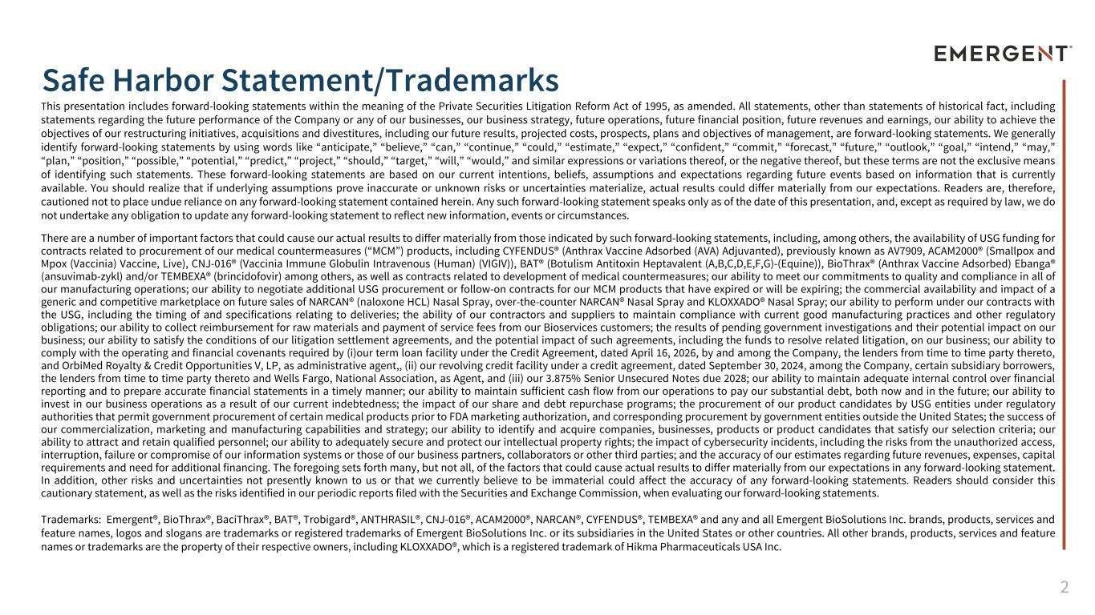
2 Safe Harbor Statement/Trademarks 2 This presentation includes forward-looking statements within the meaning of the Private Securities Litigation Reform Act of 1995, as amended. All statements, other than statements of historical fact, including statements regarding the future performance of the Company or any of our businesses, our business strategy, future operations, future financial position, future revenues and earnings, our ability to achieve the objectives of our restructuring initiatives, acquisitions and divestitures, including our future results, projected costs, prospects, plans and objectives of management, are forward-looking statements. We generally identify forward-looking statements by using words like “anticipate,” “believe,” “can,” “continue,” “could,” “estimate,” “expect,” “confident,” “commit,” “forecast,” “future,” “outlook,” “goal,” “intend,” “may,” “plan,” “position,” “possible,” “potential,” “predict,” “project,” “should,” “target,” “will,” “would,” and similar expressions or variations thereof, or the negative thereof, but these terms are not the exclusive means of identifying such statements. These forward-looking statements are based on our current intentions, beliefs, assumptions and expectations regarding future events based on information that is currently available. You should realize that if underlying assumptions prove inaccurate or unknown risks or uncertainties materialize, actual results could differ materially from our expectations. Readers are, therefore, cautioned not to place undue reliance on any forward-looking statement contained herein. Any such forward-looking statement speaks only as of the date of this presentation, and, except as required by law, we do not undertake any obligation to update any forward-looking statement to reflect new information, events or circumstances. There are a number of important factors that could cause our actual results to differ materially from those indicated by such forward-looking statements, including, among others, the availability of USG funding for contracts related to procurement of our medical countermeasures (“MCM”) products, including CYFENDUS® (Anthrax Vaccine Adsorbed (AVA) Adjuvanted), previously known as AV7909, ACAM2000® (Smallpox and Mpox (Vaccinia) Vaccine, Live), CNJ-016® (Vaccinia Immune Globulin Intravenous (Human) (VIGIV)), BAT® (Botulism Antitoxin Heptavalent (A,B,C,D,E,F,G)-(Equine)), BioThrax® (Anthrax Vaccine Adsorbed) Ebanga® (ansuvimab-zykl) and/or TEMBEXA® (brincidofovir) among others, as well as contracts related to development of medical countermeasures; our ability to meet our commitments to quality and compliance in all of our manufacturing operations; our ability to negotiate additional USG procurement or follow-on contracts for our MCM products that have expired or will be expiring; the commercial availability and impact of a generic and competitive marketplace on future sales of NARCAN® (naloxone HCL) Nasal Spray, over-the-counter NARCAN® Nasal Spray and KLOXXADO® Nasal Spray; our ability to perform under our contracts with the USG, including the timing of and specifications relating to deliveries; the ability of our contractors and suppliers to maintain compliance with current good manufacturing practices and other regulatory obligations; our ability to collect reimbursement for raw materials and payment of service fees from our Bioservices customers; the results of pending government investigations and their potential impact on our business; our ability to satisfy the conditions of our litigation settlement agreements, and the potential impact of such agreements, including the funds to resolve related litigation, on our business; our ability to comply with the operating and financial covenants required by (i)our term loan facility under the Credit Agreement, dated April 16, 2026, by and among the Company, the lenders from time to time party thereto, and OrbiMed Royalty & Credit Opportunities V, LP, as administrative agent,, (ii) our revolving credit facility under a credit agreement, dated September 30, 2024, among the Company, certain subsidiary borrowers, the lenders from time to time party thereto and Wells Fargo, National Association, as Agent, and (iii) our 3.875% Senior Unsecured Notes due 2028; our ability to maintain adequate internal control over financial reporting and to prepare accurate financial statements in a timely manner; our ability to maintain sufficient cash flow from our operations to pay our substantial debt, both now and in the future; our ability to invest in our business operations as a result of our current indebtedness; the impact of our share and debt repurchase programs; the procurement of our product candidates by USG entities under regulatory authorities that permit government procurement of certain medical products prior to FDA marketing authorization, and corresponding procurement by government entities outside the United States; the success of our commercialization, marketing and manufacturing capabilities and strategy; our ability to identify and acquire companies, businesses, products or product candidates that satisfy our selection criteria; our ability to attract and retain qualified personnel; our ability to adequately secure and protect our intellectual property rights; the impact of cybersecurity incidents, including the risks from the unauthorized access, interruption, failure or compromise of our information systems or those of our business partners, collaborators or other third parties; and the accuracy of our estimates regarding future revenues, expenses, capital requirements and need for additional financing. The foregoing sets forth many, but not all, of the factors that could cause actual results to differ materially from our expectations in any forward-looking statement. In addition, other risks and uncertainties not presently known to us or that we currently believe to be immaterial could affect the accuracy of any forward-looking statements. Readers should consider this cautionary statement, as well as the risks identified in our periodic reports filed with the Securities and Exchange Commission, when evaluating our forward-looking statements. Trademarks: Emergent®, BioThrax®, BaciThrax®, BAT®, Trobigard®, ANTHRASIL®, CNJ-016®, ACAM2000®, NARCAN®, CYFENDUS®, TEMBEXA® and any and all Emergent BioSolutions Inc. brands, products, services and feature names, logos and slogans are trademarks or registered trademarks of Emergent BioSolutions Inc. or its subsidiaries in the United States or other countries. All other brands, products, services and feature names or trademarks are the property of their respective owners, including KLOXXADO®, which is a registered trademark of Hikma Pharmaceuticals USA Inc.

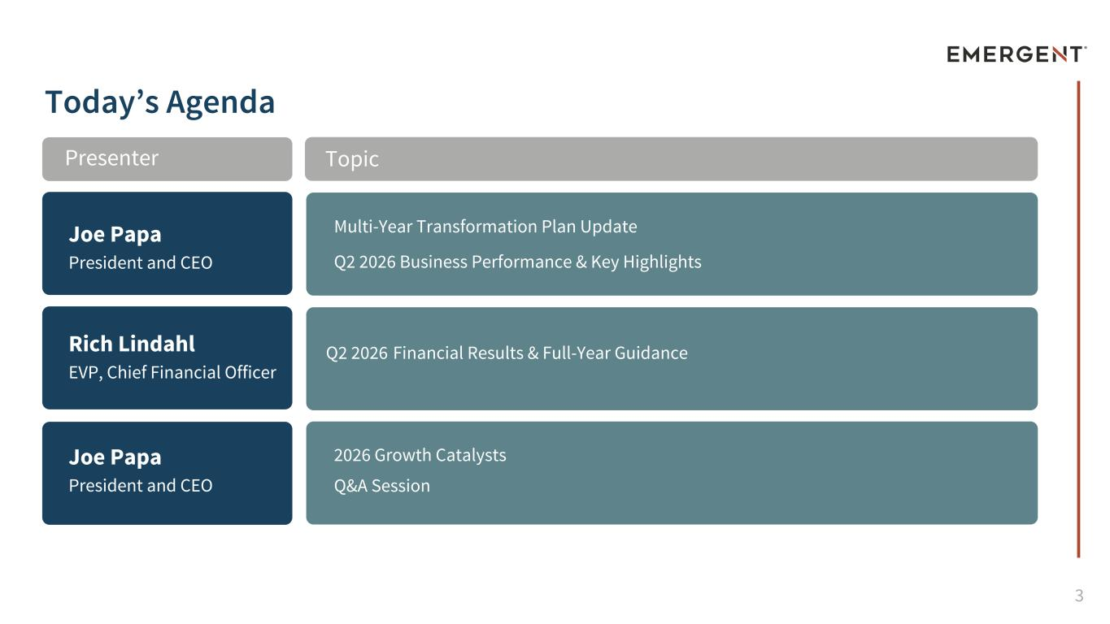
3 Today’s Agenda Joe Papa President and CEO Rich Lindahl EVP, Chief Financial Officer Joe Papa President and CEO Multi-Year Transformation Plan Update Q2 2026 Business Performance & Key Highlights Q2 2026 Financial Results & Full-Year Guidance 2026 Growth Catalysts Q&A Session TopicPresenter


4 Multi-Year Transformation Plan Update Joe Papa President and Chief Executive Officer

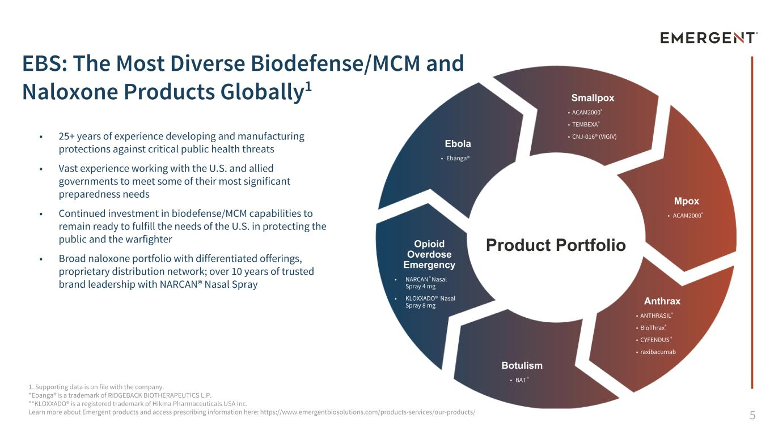
5 1. Supporting data is on file with the company. *Ebanga® is a trademark of RIDGEBACK BIOTHERAPEUTICS L.P. **KLOXXADO® is a registered trademark of Hikma Pharmaceuticals USA Inc. Learn more about Emergent products and access prescribing information here: https://www.emergentbiosolutions.com/products-services/our-products/ • 25+ years of experience developing and manufacturing protections against critical public health threats • Vast experience working with the U.S. and allied governments to meet some of their most significant preparedness needs • Continued investment in biodefense/MCM capabilities to remain ready to fulfill the needs of the U.S. in protecting the public and the warfighter • Broad naloxone portfolio with differentiated offerings, proprietary distribution network; over 10 years of trusted brand leadership with NARCAN® Nasal Spray EBS: The Most Diverse Biodefense/MCM and Naloxone Products Globally1 Product Portfolio Smallpox • ACAM2000® • TEMBEXA® • CNJ-016® (VIGIV) Anthrax • ANTHRASIL® • BioThrax® • CYFENDUS ® • raxibacumab Opioid Overdose Emergency • NARCAN ® Nasal Spray 4 mg • KLOXXADO® Nasal Spray 8 mg Botulism • BAT ® Ebola • Ebanga® Mpox • ACAM2000®

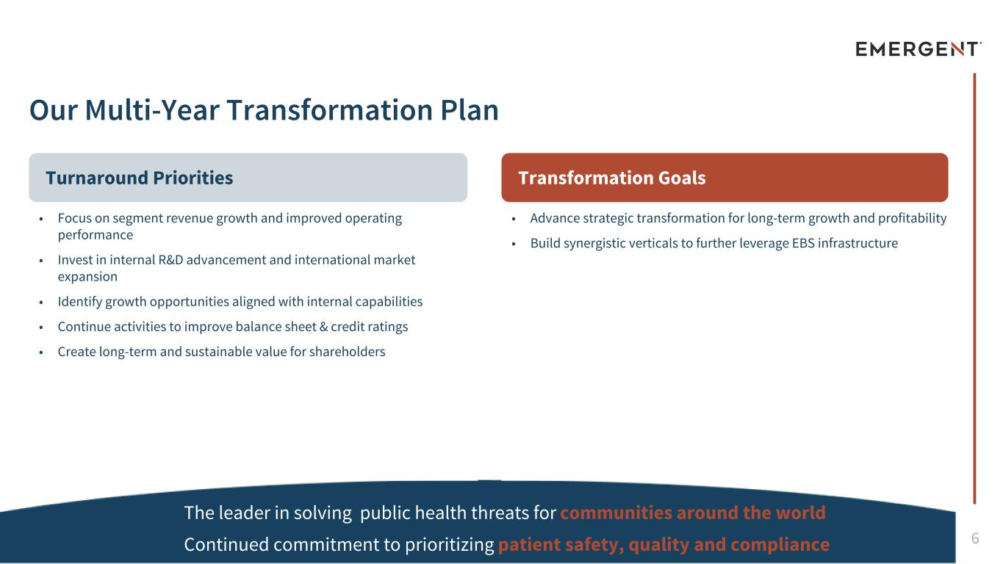
6 Transformation Goals Our Multi-Year Transformation Plan Turnaround Priorities The leader in solving public health threats for communities around the world Continued commitment to prioritizing patient safety, quality and compliance • Focus on segment revenue growth and improved operating performance • Invest in internal R&D advancement and international market expansion • Identify growth opportunities aligned with internal capabilities • Continue activities to improve balance sheet & credit ratings • Create long-term and sustainable value for shareholders • Advance strategic transformation for long-term growth and profitability • Build synergistic verticals to further leverage EBS infrastructure

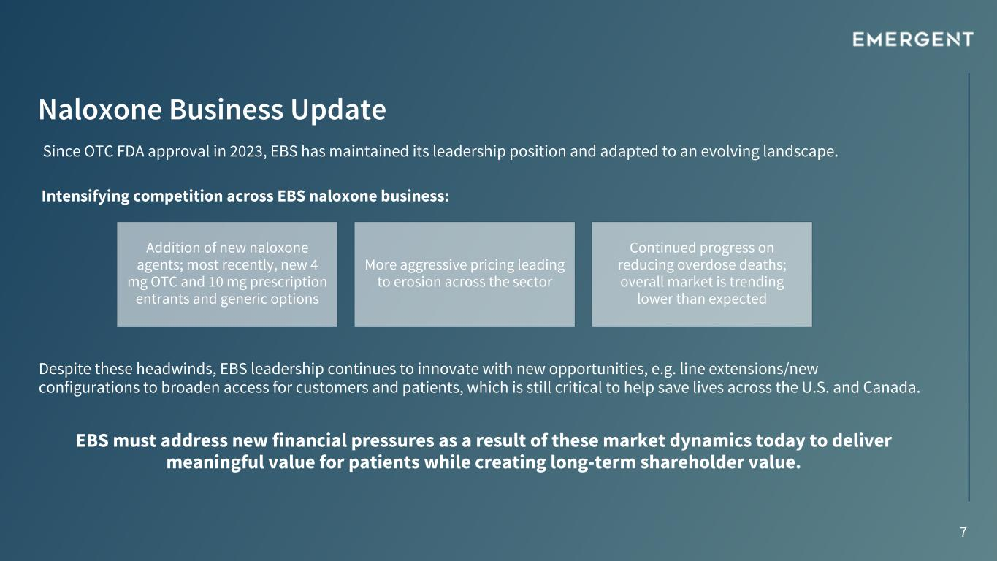
7 Naloxone Business Update Intensifying competition across EBS naloxone business: Since OTC FDA approval in 2023, EBS has maintained its leadership position and adapted to an evolving landscape. EBS must address new financial pressures as a result of these market dynamics today to deliver meaningful value for patients while creating long-term shareholder value. Addition of new naloxone agents; most recently, new 4 mg OTC and 10 mg prescription entrants and generic options More aggressive pricing leading to erosion across the sector Continued progress on reducing overdose deaths; overall market is trending lower than expected Despite these headwinds, EBS leadership continues to innovate with new opportunities, e.g. line extensions/new configurations to broaden access for customers and patients, which is still critical to help save lives across the U.S. and Canada.

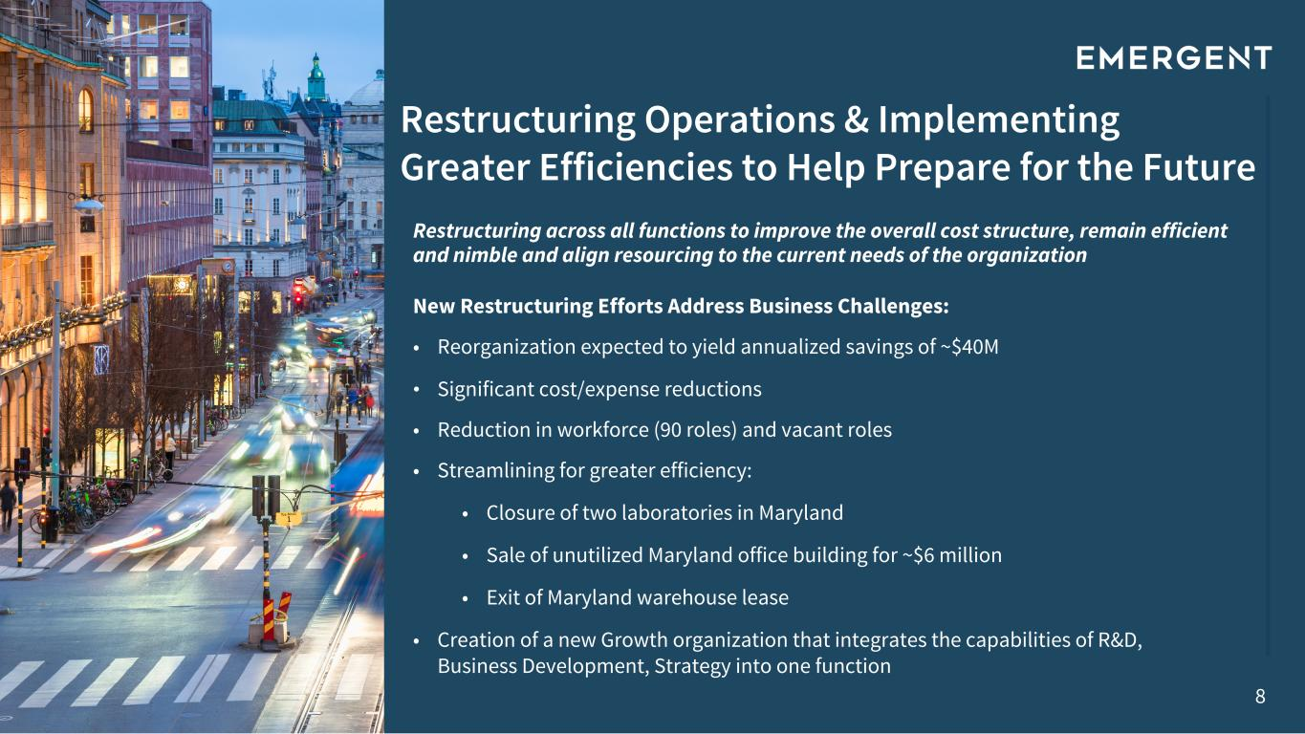
8 Restructuring Operations & Implementing Greater Efficiencies to Help Prepare for the Future New Restructuring Efforts Address Business Challenges: • Reorganization expected to yield annualized savings of ~$40M • Significant cost/expense reductions • Reduction in workforce (90 roles) and vacant roles • Streamlining for greater efficiency: • Closure of two laboratories in Maryland • Sale of unutilized Maryland office building for ~$6 million • Exit of Maryland warehouse lease • Creation of a new Growth organization that integrates the capabilities of R&D, Business Development, Strategy into one function Restructuring across all functions to improve the overall cost structure, remain efficient and nimble and align resourcing to the current needs of the organization


9 2026 Business Performance & Key Highlights Joe Papa President and Chief Executive Officer 9

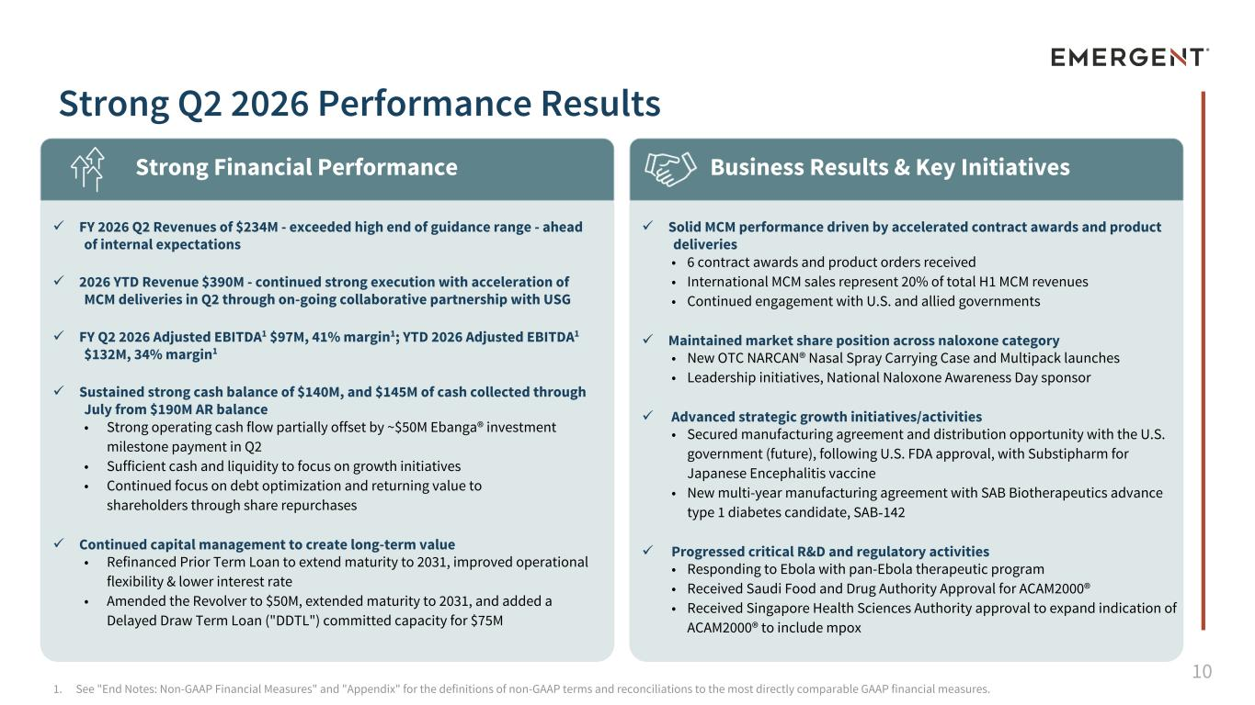
10 ü Solid MCM performance driven by accelerated contract awards and product deliveries • 6 contract awards and product orders received • International MCM sales represent 20% of total H1 MCM revenues • Continued engagement with U.S. and allied governments ü Maintained market share position across naloxone category • New OTC NARCAN® Nasal Spray Carrying Case and Multipack launches • Leadership initiatives, National Naloxone Awareness Day sponsor ü Advanced strategic growth initiatives/activities • Secured manufacturing agreement and distribution opportunity with the U.S. government (future), following U.S. FDA approval, with Substipharm for Japanese Encephalitis vaccine • New multi-year manufacturing agreement with SAB Biotherapeutics advance type 1 diabetes candidate, SAB-142 ü Progressed critical R&D and regulatory activities • Responding to Ebola with pan-Ebola therapeutic program • Received Saudi Food and Drug Authority Approval for ACAM2000® • Received Singapore Health Sciences Authority approval to expand indication of ACAM2000® to include mpox ü FY 2026 Q2 Revenues of $234M - exceeded high end of guidance range - ahead of internal expectations ü 2026 YTD Revenue $390M - continued strong execution with acceleration of MCM deliveries in Q2 through on-going collaborative partnership with USG ü FY Q2 2026 Adjusted EBITDA1 $97M, 41% margin1; YTD 2026 Adjusted EBITDA1 $132M, 34% margin1 ü Sustained strong cash balance of $140M, and $145M of cash collected through July from $190M AR balance • Strong operating cash flow partially offset by ~$50M Ebanga® investment milestone payment in Q2 • Sufficient cash and liquidity to focus on growth initiatives • Continued focus on debt optimization and returning value to shareholders through share repurchases ü Continued capital management to create long-term value • Refinanced Prior Term Loan to extend maturity to 2031, improved operational flexibility & lower interest rate • Amended the Revolver to $50M, extended maturity to 2031, and added a Delayed Draw Term Loan ("DDTL") committed capacity for $75M 1. See "End Notes: Non-GAAP Financial Measures" and "Appendix" for the definitions of non-GAAP terms and reconciliations to the most directly comparable GAAP financial measures. Strong Financial Performance Business Results & Key Initiatives Strong Q2 2026 Performance Results

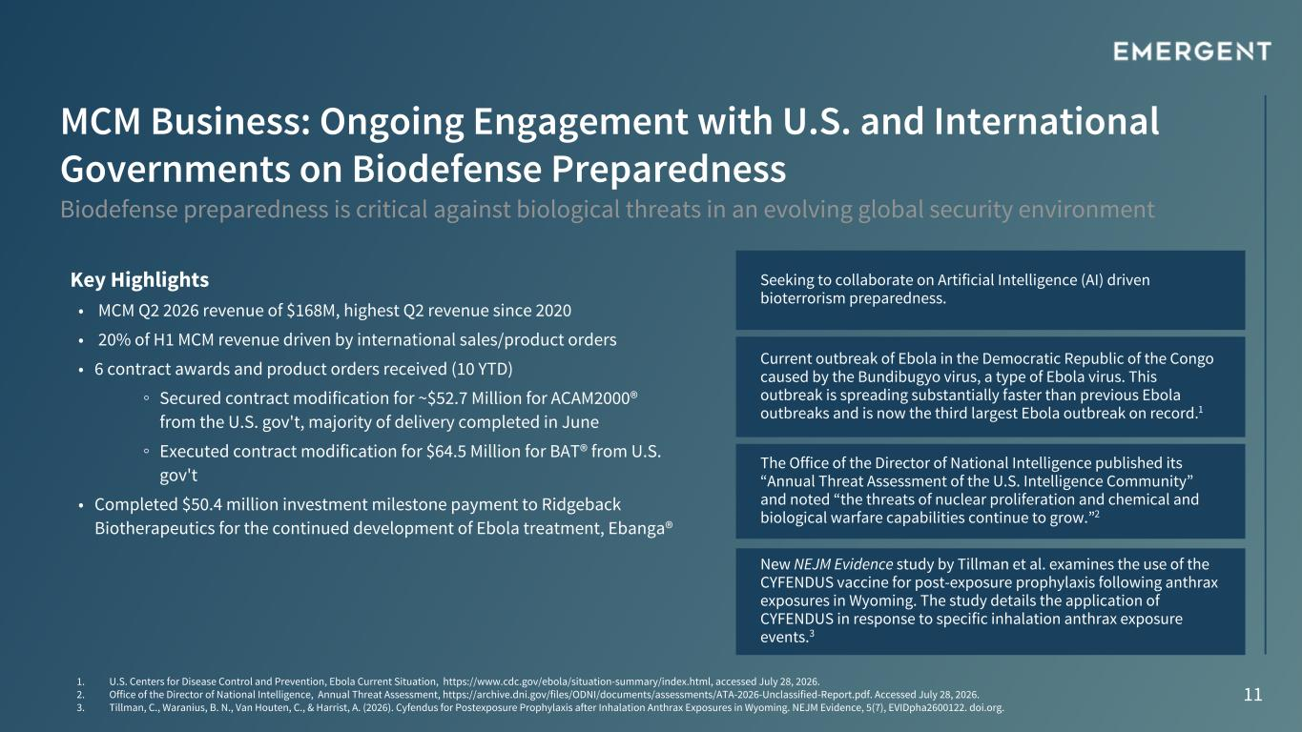
11 MCM Business: Ongoing Engagement with U.S. and International Governments on Biodefense Preparedness Biodefense preparedness is critical against biological threats in an evolving global security environment Current outbreak of Ebola in the Democratic Republic of the Congo caused by the Bundibugyo virus, a type of Ebola virus. This outbreak is spreading substantially faster than previous Ebola outbreaks and is now the third largest Ebola outbreak on record.1 1. U.S. Centers for Disease Control and Prevention, Ebola Current Situation, https://www.cdc.gov/ebola/situation-summary/index.html, accessed July 28, 2026. 2. Office of the Director of National Intelligence, Annual Threat Assessment, https://archive.dni.gov/files/ODNI/documents/assessments/ATA-2026-Unclassified-Report.pdf. Accessed July 28, 2026. 3. Tillman, C., Waranius, B. N., Van Houten, C., & Harrist, A. (2026). Cyfendus for Postexposure Prophylaxis after Inhalation Anthrax Exposures in Wyoming. NEJM Evidence, 5(7), EVIDpha2600122. doi.org. Key Highlights • MCM Q2 2026 revenue of $168M, highest Q2 revenue since 2020 • 20% of H1 MCM revenue driven by international sales/product orders • 6 contract awards and product orders received (10 YTD) ◦ Secured contract modification for ~$52.7 Million for ACAM2000® from the U.S. gov't, majority of delivery completed in June ◦ Executed contract modification for $64.5 Million for BAT® from U.S. gov't • Completed $50.4 million investment milestone payment to Ridgeback Biotherapeutics for the continued development of Ebola treatment, Ebanga® New NEJM Evidence study by Tillman et al. examines the use of the CYFENDUS vaccine for post-exposure prophylaxis following anthrax exposures in Wyoming. The study details the application of CYFENDUS in response to specific inhalation anthrax exposure events.3 The Office of the Director of National Intelligence published its “Annual Threat Assessment of the U.S. Intelligence Community” and noted “the threats of nuclear proliferation and chemical and biological warfare capabilities continue to grow.”2 Seeking to collaborate on Artificial Intelligence (AI) driven bioterrorism preparedness.


12 Q2 2026 Financial Results & Full-Year Guidance Rich Lindahl EVP, Chief Financial Officer

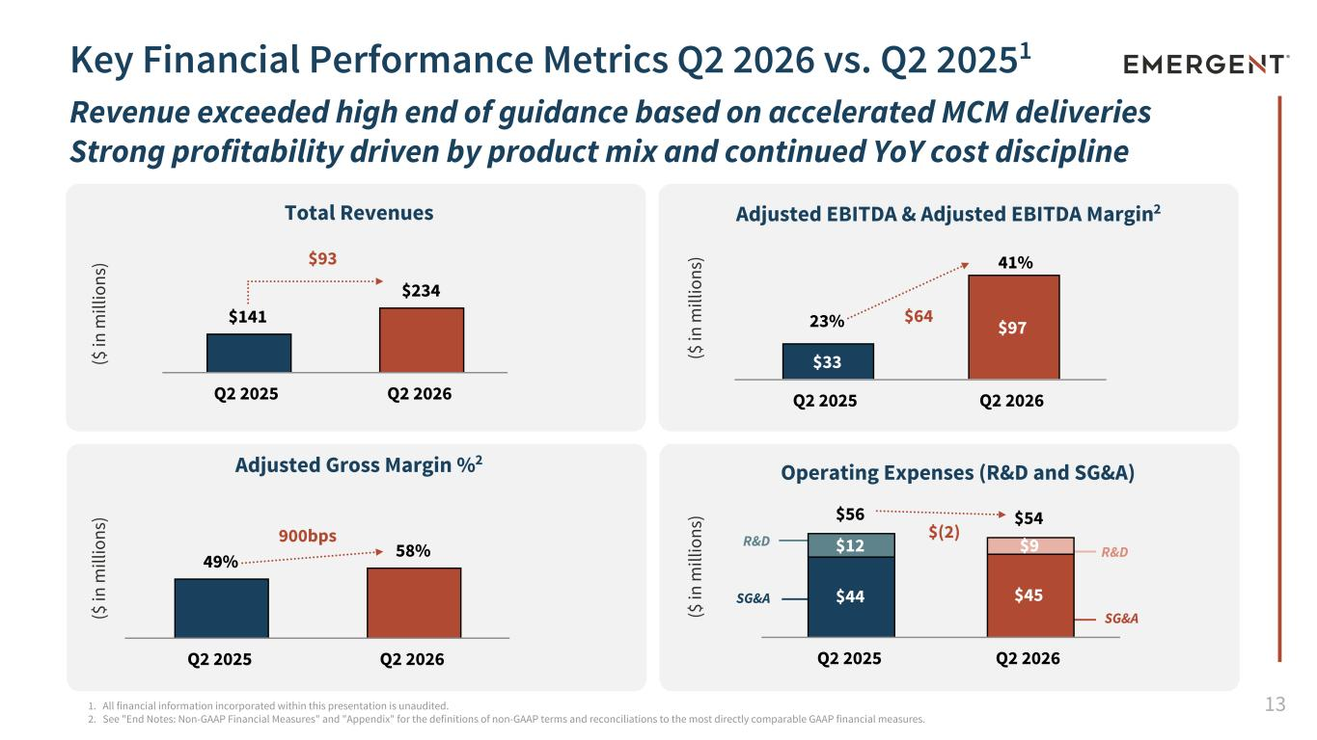
13 Key Financial Performance Metrics Q2 2026 vs. Q2 20251 Revenue exceeded high end of guidance based on accelerated MCM deliveries Strong profitability driven by product mix and continued YoY cost discipline Adjusted Gross Margin %2 ($ in m ill io ns ) ($ in m ill io ns ) ($ in m ill io ns ) ($ in m ill io ns ) Total Revenues 1. All financial information incorporated within this presentation is unaudited. 2. See "End Notes: Non-GAAP Financial Measures" and "Appendix" for the definitions of non-GAAP terms and reconciliations to the most directly comparable GAAP financial measures. Adjusted EBITDA & Adjusted EBITDA Margin2 Operating Expenses (R&D and SG&A) R&D SG&A R&D SG&A $141 $234 Q2 2025 Q2 2026 $33 $97 Q2 2025 Q2 2026 49% 58% Q2 2025 Q2 2026 $56 $54 $44 $45 $12 $9 Q2 2025 Q2 2026 23% $64 41% $(2) $93 900bps

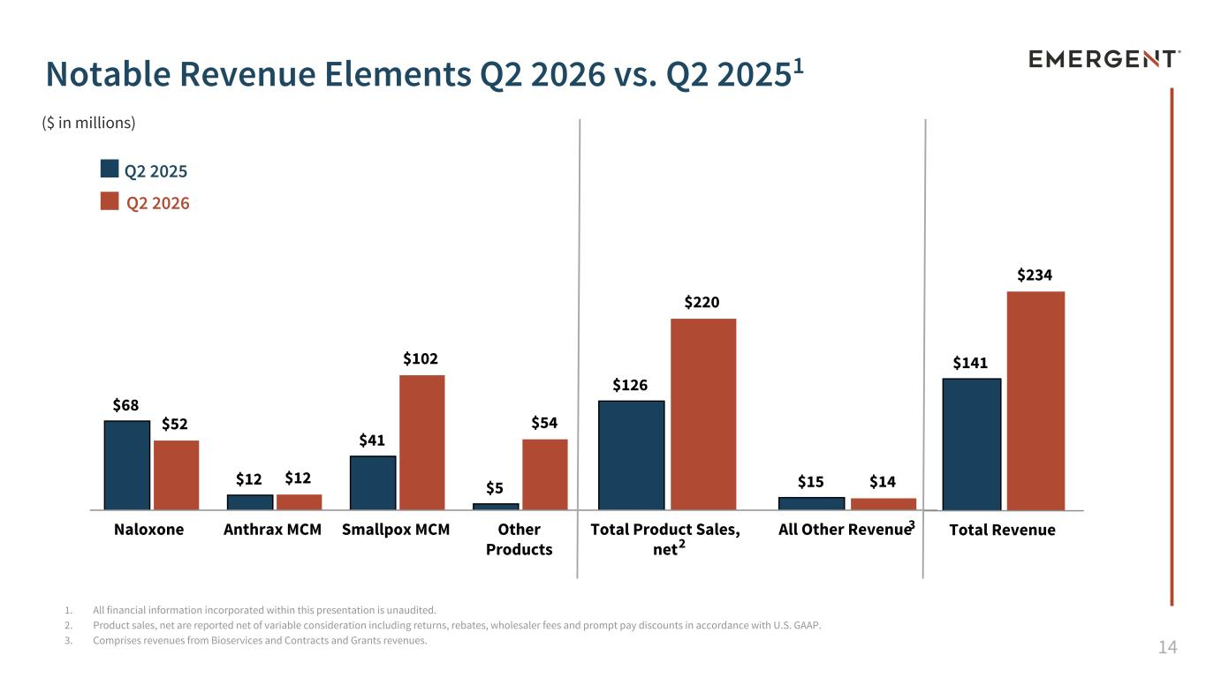
14 $141 $234 Total Revenue $126 $15 $220 $14 Total Product Sales, net All Other Revenue 1. All financial information incorporated within this presentation is unaudited. 2. Product sales, net are reported net of variable consideration including returns, rebates, wholesaler fees and prompt pay discounts in accordance with U.S. GAAP. 3. Comprises revenues from Bioservices and Contracts and Grants revenues. Notable Revenue Elements Q2 2026 vs. Q2 20251 $68 $12 $41 $5 $52 $12 $102 $54 Naloxone Anthrax MCM Smallpox MCM Other Products Q2 2025 Q2 2026 ($ in millions) 2 3

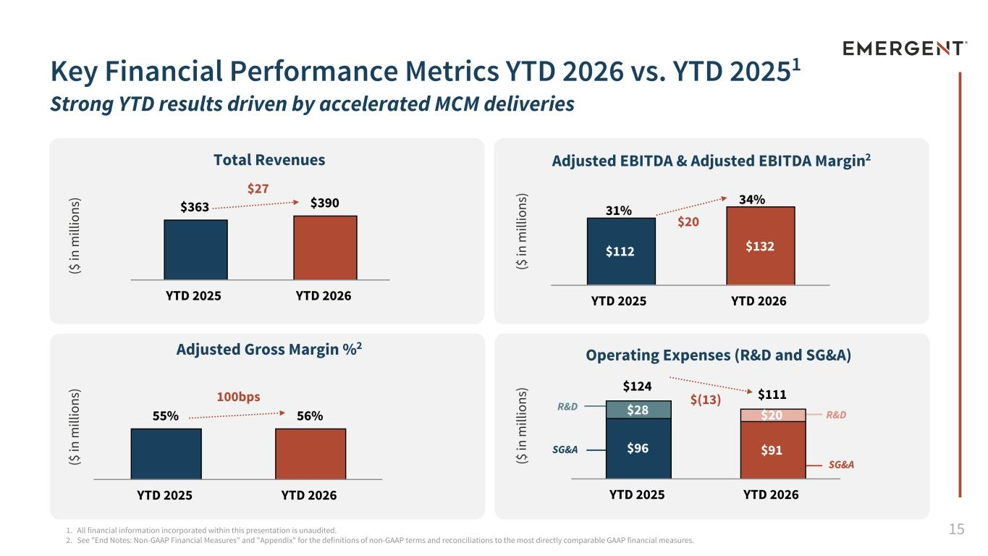
15 Key Financial Performance Metrics YTD 2026 vs. YTD 20251 Strong YTD results driven by accelerated MCM deliveries Adjusted Gross Margin %2 ($ in m ill io ns ) ($ in m ill io ns ) ($ in m ill io ns ) ($ in m ill io ns ) Total Revenues 1. All financial information incorporated within this presentation is unaudited. 2. See "End Notes: Non-GAAP Financial Measures" and "Appendix" for the definitions of non-GAAP terms and reconciliations to the most directly comparable GAAP financial measures. Adjusted EBITDA & Adjusted EBITDA Margin2 Operating Expenses (R&D and SG&A) R&D SG&A R&D SG&A $363 $390 YTD 2025 YTD 2026 $112 $132 YTD 2025 YTD 2026 55% 56% YTD 2025 YTD 2026 $124 $111 $96 $91 $28 $20 YTD 2025 YTD 2026 31% $20 34% $(13) $27 100bps

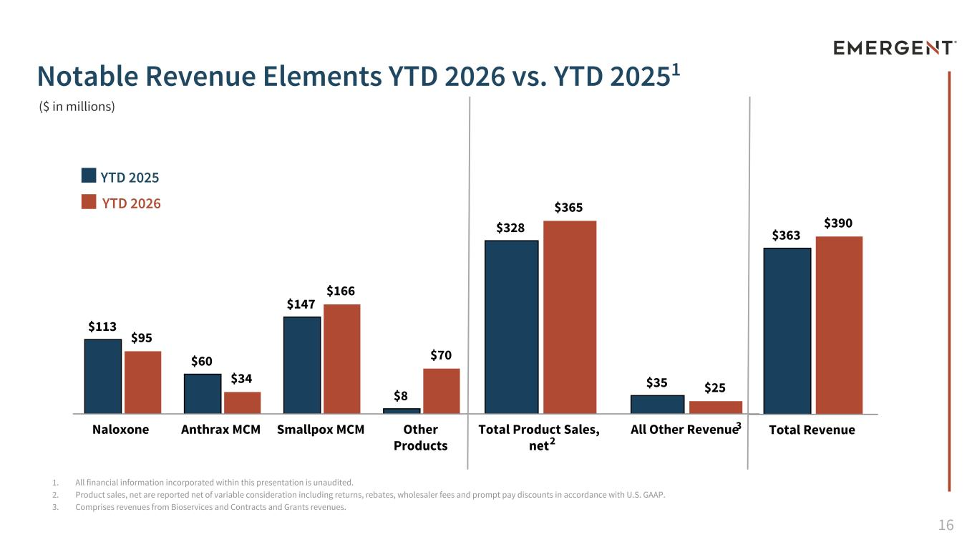
16 $363 $390 Total Revenue $328 $35 $365 $25 Total Product Sales, net All Other Revenue 1. All financial information incorporated within this presentation is unaudited. 2. Product sales, net are reported net of variable consideration including returns, rebates, wholesaler fees and prompt pay discounts in accordance with U.S. GAAP. 3. Comprises revenues from Bioservices and Contracts and Grants revenues. Notable Revenue Elements YTD 2026 vs. YTD 20251 $113 $60 $147 $8 $95 $34 $166 $70 Naloxone Anthrax MCM Smallpox MCM Other Products YTD 2025 YTD 2026 ($ in millions) 2 3

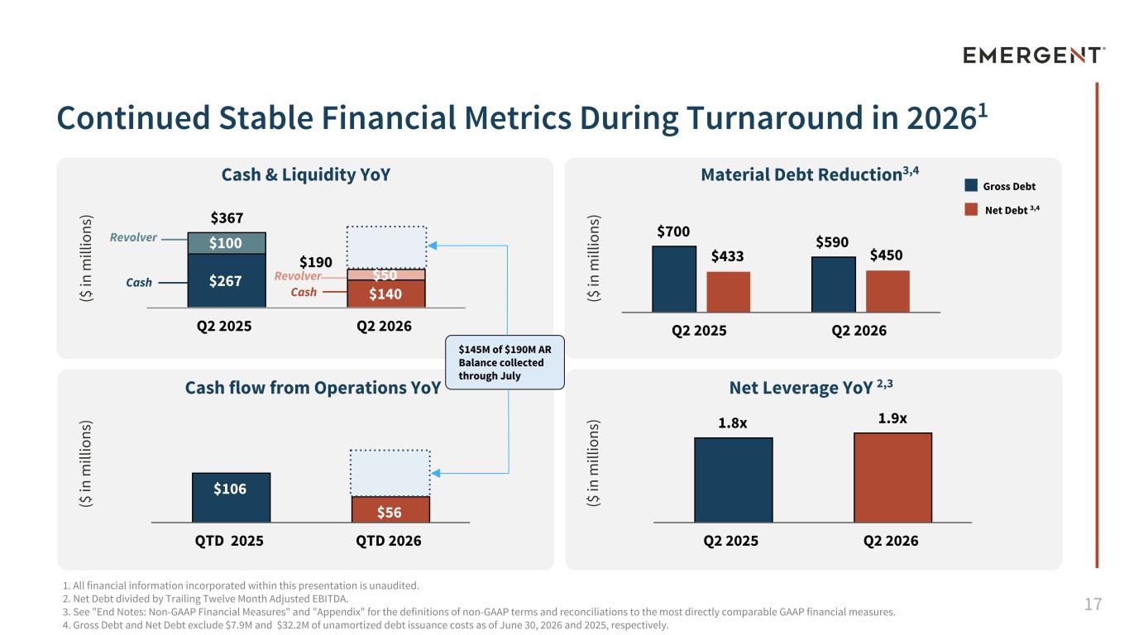
17 1. All financial information incorporated within this presentation is unaudited. 2. Net Debt divided by Trailing Twelve Month Adjusted EBITDA. 3. See "End Notes: Non-GAAP Financial Measures" and "Appendix" for the definitions of non-GAAP terms and reconciliations to the most directly comparable GAAP financial measures. 4. Gross Debt and Net Debt exclude $7.9M and $32.2M of unamortized debt issuance costs as of June 30, 2026 and 2025, respectively. Continued Stable Financial Metrics During Turnaround in 20261 Cash & Liquidity YoY Material Debt Reduction3,4 Net Leverage YoY 2,3Cash flow from Operations YoY Revolver Revolver Cash Cash ($ in m ill io ns ) ($ in m ill io ns ) ($ in m ill io ns ) ($ in m ill io ns ) Gross Debt Net Debt 3,4 $700 $590 $433 $450 Q2 2025 Q2 2026 1.8x 1.9x Q2 2025 Q2 2026 $267 $140 $100 $50 Q2 2025 Q2 2026 $106 $56 QTD 2025 QTD 2026 $145M of $190M AR Balance collected through July $367 $190

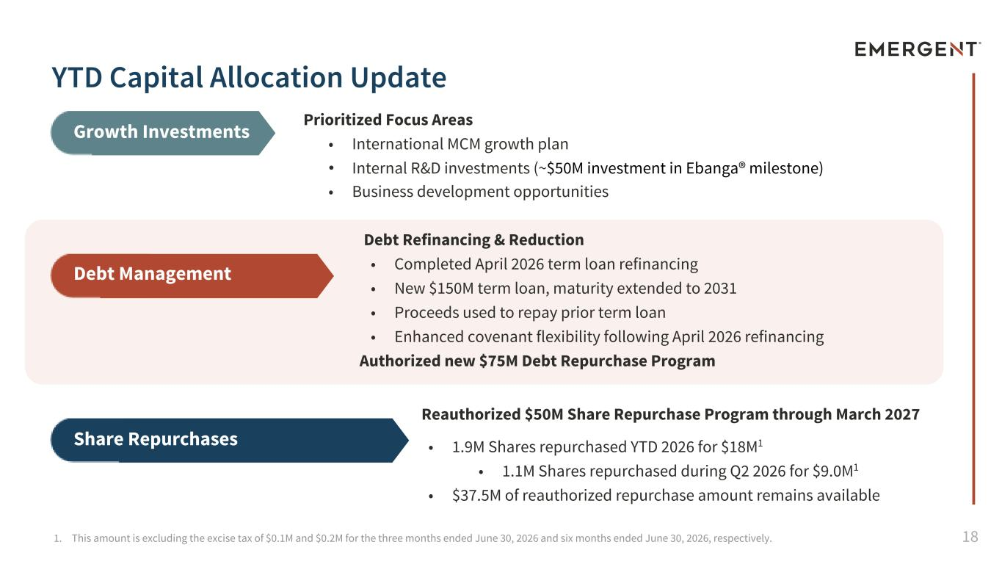
181. This amount is excluding the excise tax of $0.1M and $0.2M for the three months ended June 30, 2026 and six months ended June 30, 2026, respectively. Prioritized Focus Areas • International MCM growth plan • Internal R&D investments (~$50M investment in Ebanga® milestone) • Business development opportunities Growth Investments Debt Refinancing & Reduction • Completed April 2026 term loan refinancing • New $150M term loan, maturity extended to 2031 • Proceeds used to repay prior term loan • Enhanced covenant flexibility following April 2026 refinancing Authorized new $75M Debt Repurchase Program Debt Management Reauthorized $50M Share Repurchase Program through March 2027 • 1.9M Shares repurchased YTD 2026 for $18M1 • 1.1M Shares repurchased during Q2 2026 for $9.0M1 • $37.5M of reauthorized repurchase amount remains available Share Repurchases YTD Capital Allocation Update

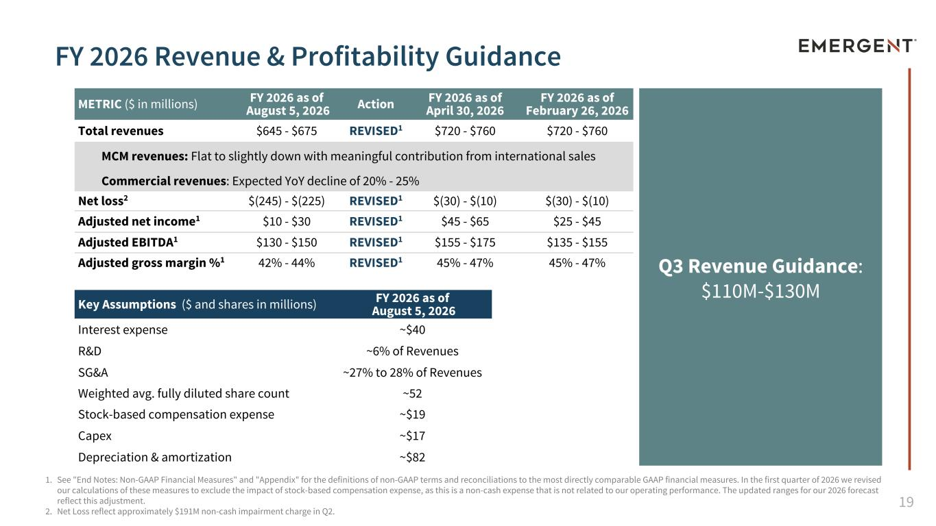
19 METRIC ($ in millions) FY 2026 as of August 5, 2026 Action FY 2026 as of April 30, 2026 FY 2026 as of February 26, 2026 Total revenues $645 - $675 REVISED1 $720 - $760 $720 - $760 MCM revenues: Flat to slightly down with meaningful contribution from international sales Commercial revenues: Expected YoY decline of 20% - 25% Net loss2 $(245) - $(225) REVISED1 $(30) - $(10) $(30) - $(10) Adjusted net income1 $10 - $30 REVISED1 $45 - $65 $25 - $45 Adjusted EBITDA1 $130 - $150 REVISED1 $155 - $175 $135 - $155 Adjusted gross margin %1 42% - 44% REVISED1 45% - 47% 45% - 47% Key Assumptions ($ and shares in millions) FY 2026 as of August 5, 2026 Interest expense ~$40 R&D ~6% of Revenues SG&A ~27% to 28% of Revenues Weighted avg. fully diluted share count ~52 Stock-based compensation expense ~$19 Capex ~$17 Depreciation & amortization ~$82 1. See "End Notes: Non-GAAP Financial Measures" and "Appendix" for the definitions of non-GAAP terms and reconciliations to the most directly comparable GAAP financial measures. In the first quarter of 2026 we revised our calculations of these measures to exclude the impact of stock-based compensation expense, as this is a non-cash expense that is not related to our operating performance. The updated ranges for our 2026 forecast reflect this adjustment. 2. Net Loss reflect approximately $191M non-cash impairment charge in Q2. FY 2026 Revenue & Profitability Guidance Q3 Revenue Guidance: $110M-$130M

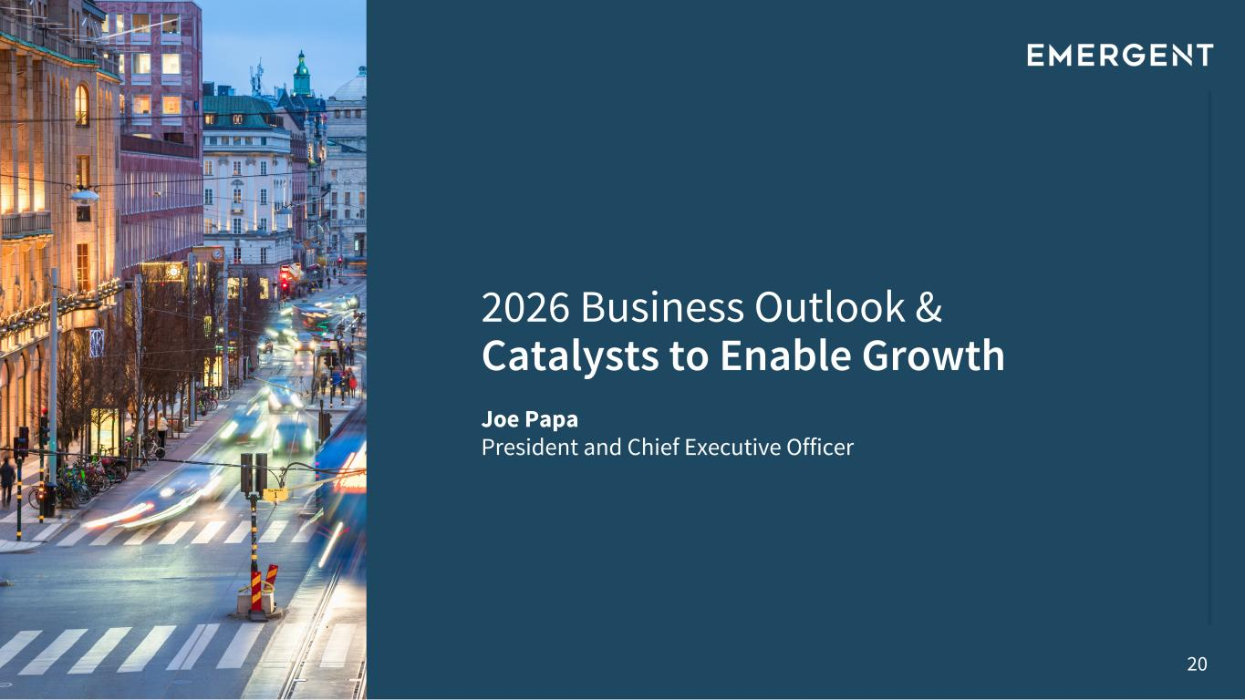
20 2026 Business Outlook & Catalysts to Enable Growth Joe Papa President and Chief Executive Officer

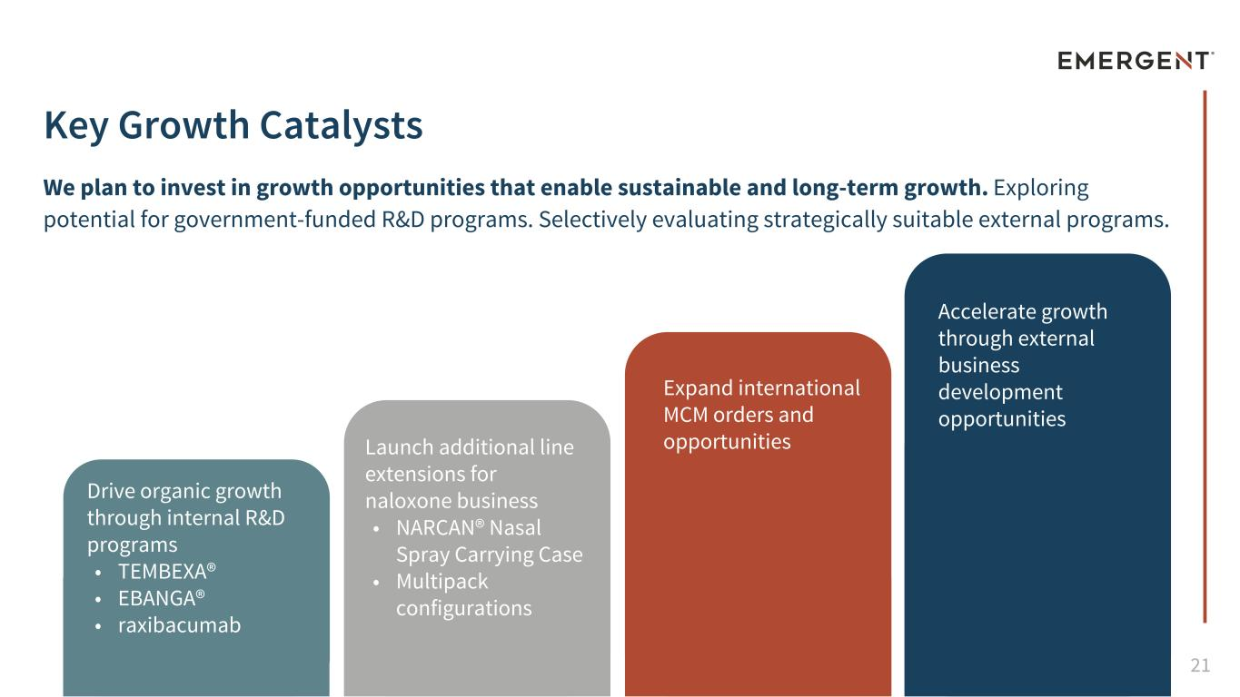
21 Key Growth Catalysts Drive organic growth through internal R&D programs • TEMBEXA® • EBANGA® • raxibacumab We plan to invest in growth opportunities that enable sustainable and long-term growth. Exploring potential for government-funded R&D programs. Selectively evaluating strategically suitable external programs. Launch additional line extensions for naloxone business • NARCAN® Nasal Spray Carrying Case • Multipack configurations Expand international MCM orders and opportunities Accelerate growth through external business development opportunities

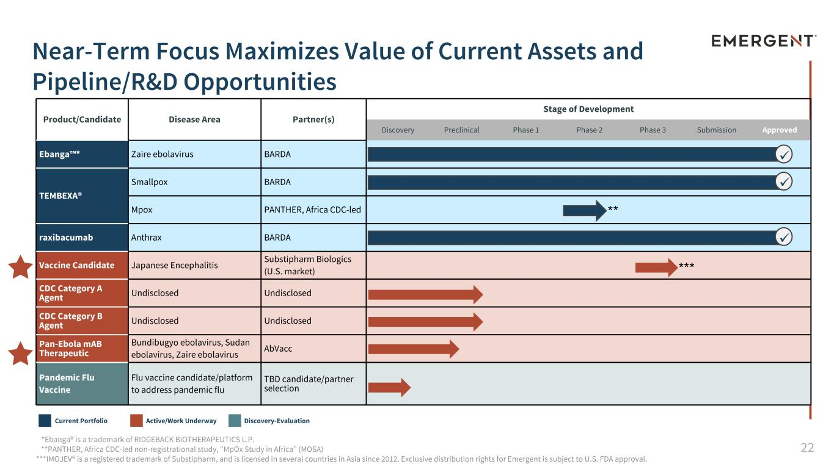
22 Product/Candidate Disease Area Partner(s) Stage of Development Discovery Preclinical Phase 1 Phase 2 Phase 3 Submission Approved Ebanga™* Zaire ebolavirus BARDA TEMBEXA® Smallpox BARDA Mpox PANTHER, Africa CDC-led raxibacumab Anthrax BARDA Vaccine Candidate Japanese Encephalitis Substipharm Biologics (U.S. market) CDC Category A Agent Undisclosed Undisclosed CDC Category B Agent Undisclosed Undisclosed Pan-Ebola mAB Therapeutic Bundibugyo ebolavirus, Sudan ebolavirus, Zaire ebolavirus AbVacc Pandemic Flu Vaccine Flu vaccine candidate/platform to address pandemic flu TBD candidate/partner selection Near-Term Focus Maximizes Value of Current Assets and Pipeline/R&D Opportunities *Ebanga® is a trademark of RIDGEBACK BIOTHERAPEUTICS L.P. **PANTHER, Africa CDC-led non-registrational study, “MpOx Study in Africa” (MOSA) ***IMOJEV® is a registered trademark of Substipharm, and is licensed in several countries in Asia since 2012. Exclusive distribution rights for Emergent is subject to U.S. FDA approval. Current Portfolio Active/Work Underway Discovery-Evaluation ü ** ü ü ***Í Í

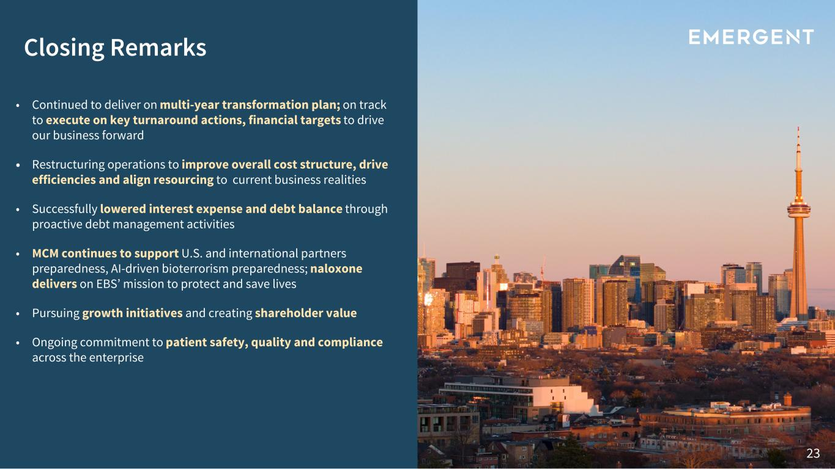
23 • Continued to deliver on multi-year transformation plan; on track to execute on key turnaround actions, financial targets to drive our business forward • Restructuring operations to improve overall cost structure, drive efficiencies and align resourcing to current business realities • Successfully lowered interest expense and debt balance through proactive debt management activities • MCM continues to support U.S. and international partners preparedness, AI-driven bioterrorism preparedness; naloxone delivers on EBS’ mission to protect and save lives • Pursuing growth initiatives and creating shareholder value • Ongoing commitment to patient safety, quality and compliance across the enterprise Closing Remarks


24 Q&A Session Questions? Answers.

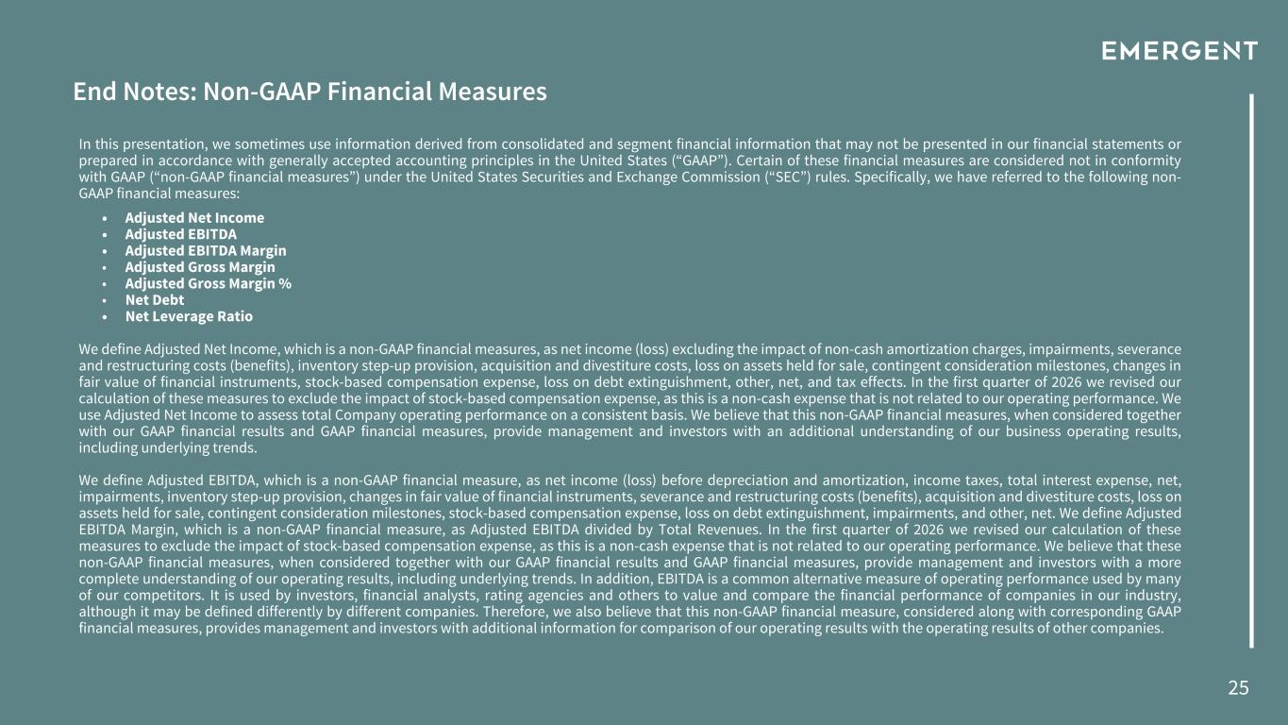
25 End Notes: Non-GAAP Financial Measures In this presentation, we sometimes use information derived from consolidated and segment financial information that may not be presented in our financial statements or prepared in accordance with generally accepted accounting principles in the United States (“GAAP”). Certain of these financial measures are considered not in conformity with GAAP (“non-GAAP financial measures”) under the United States Securities and Exchange Commission (“SEC”) rules. Specifically, we have referred to the following non- GAAP financial measures: • Adjusted Net Income • Adjusted EBITDA • Adjusted EBITDA Margin • Adjusted Gross Margin • Adjusted Gross Margin % • Net Debt • Net Leverage Ratio We define Adjusted Net Income, which is a non-GAAP financial measures, as net income (loss) excluding the impact of non-cash amortization charges, impairments, severance and restructuring costs (benefits), inventory step-up provision, acquisition and divestiture costs, loss on assets held for sale, contingent consideration milestones, changes in fair value of financial instruments, stock-based compensation expense, loss on debt extinguishment, other, net, and tax effects. In the first quarter of 2026 we revised our calculation of these measures to exclude the impact of stock-based compensation expense, as this is a non-cash expense that is not related to our operating performance. We use Adjusted Net Income to assess total Company operating performance on a consistent basis. We believe that this non-GAAP financial measures, when considered together with our GAAP financial results and GAAP financial measures, provide management and investors with an additional understanding of our business operating results, including underlying trends. We define Adjusted EBITDA, which is a non-GAAP financial measure, as net income (loss) before depreciation and amortization, income taxes, total interest expense, net, impairments, inventory step-up provision, changes in fair value of financial instruments, severance and restructuring costs (benefits), acquisition and divestiture costs, loss on assets held for sale, contingent consideration milestones, stock-based compensation expense, loss on debt extinguishment, impairments, and other, net. We define Adjusted EBITDA Margin, which is a non-GAAP financial measure, as Adjusted EBITDA divided by Total Revenues. In the first quarter of 2026 we revised our calculation of these measures to exclude the impact of stock-based compensation expense, as this is a non-cash expense that is not related to our operating performance. We believe that these non-GAAP financial measures, when considered together with our GAAP financial results and GAAP financial measures, provide management and investors with a more complete understanding of our operating results, including underlying trends. In addition, EBITDA is a common alternative measure of operating performance used by many of our competitors. It is used by investors, financial analysts, rating agencies and others to value and compare the financial performance of companies in our industry, although it may be defined differently by different companies. Therefore, we also believe that this non-GAAP financial measure, considered along with corresponding GAAP financial measures, provides management and investors with additional information for comparison of our operating results with the operating results of other companies.

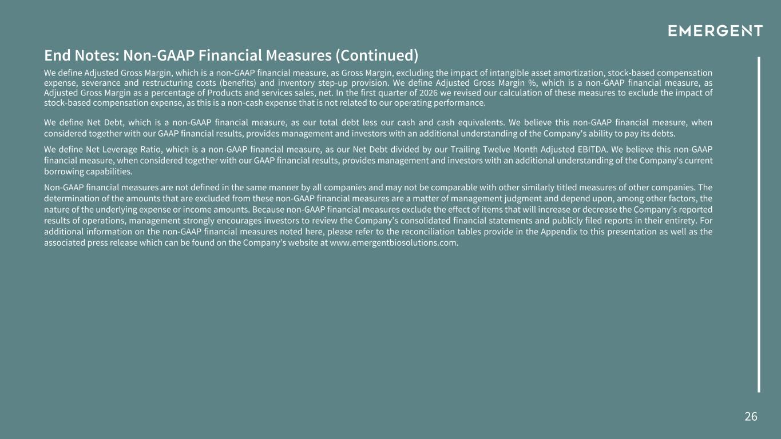
26 End Notes: Non-GAAP Financial Measures (Continued) We define Adjusted Gross Margin, which is a non-GAAP financial measure, as Gross Margin, excluding the impact of intangible asset amortization, stock-based compensation expense, severance and restructuring costs (benefits) and inventory step-up provision. We define Adjusted Gross Margin %, which is a non-GAAP financial measure, as Adjusted Gross Margin as a percentage of Products and services sales, net. In the first quarter of 2026 we revised our calculation of these measures to exclude the impact of stock-based compensation expense, as this is a non-cash expense that is not related to our operating performance. We define Net Debt, which is a non-GAAP financial measure, as our total debt less our cash and cash equivalents. We believe this non-GAAP financial measure, when considered together with our GAAP financial results, provides management and investors with an additional understanding of the Company's ability to pay its debts. We define Net Leverage Ratio, which is a non-GAAP financial measure, as our Net Debt divided by our Trailing Twelve Month Adjusted EBITDA. We believe this non-GAAP financial measure, when considered together with our GAAP financial results, provides management and investors with an additional understanding of the Company's current borrowing capabilities. Non-GAAP financial measures are not defined in the same manner by all companies and may not be comparable with other similarly titled measures of other companies. The determination of the amounts that are excluded from these non-GAAP financial measures are a matter of management judgment and depend upon, among other factors, the nature of the underlying expense or income amounts. Because non-GAAP financial measures exclude the effect of items that will increase or decrease the Company’s reported results of operations, management strongly encourages investors to review the Company’s consolidated financial statements and publicly filed reports in their entirety. For additional information on the non-GAAP financial measures noted here, please refer to the reconciliation tables provide in the Appendix to this presentation as well as the associated press release which can be found on the Company’s website at www.emergentbiosolutions.com.

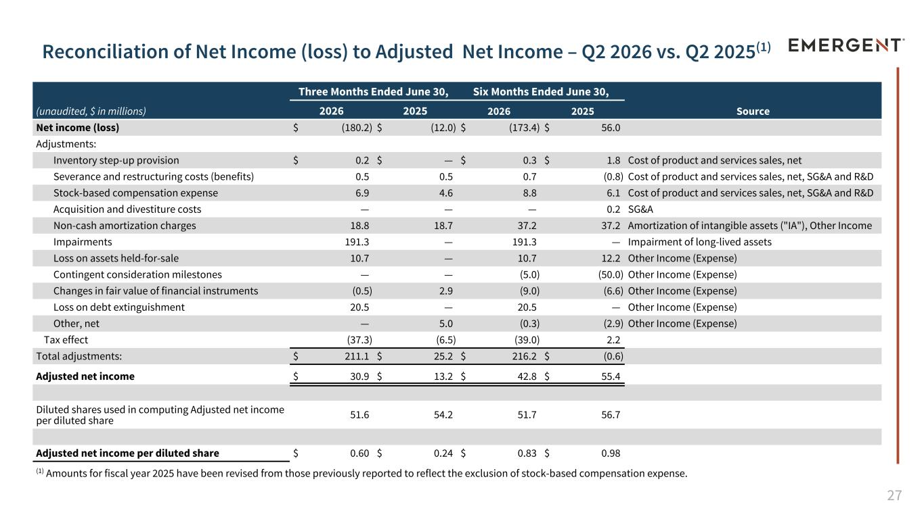
27 Reconciliation of Net Income (loss) to Adjusted Net Income – Q2 2026 vs. Q2 2025(1) (unaudited, $ in millions) Three Months Ended June 30, Six Months Ended June 30, 2026 2025 2026 2025 Source Net income (loss) $ (180.2) $ (12.0) $ (173.4) $ 56.0 Adjustments: Inventory step-up provision $ 0.2 $ — $ 0.3 $ 1.8 Cost of product and services sales, net Severance and restructuring costs (benefits) 0.5 0.5 0.7 (0.8) Cost of product and services sales, net, SG&A and R&D Stock-based compensation expense 6.9 4.6 8.8 6.1 Cost of product and services sales, net, SG&A and R&D Acquisition and divestiture costs — — — 0.2 SG&A Non-cash amortization charges 18.8 18.7 37.2 37.2 Amortization of intangible assets ("IA"), Other Income Impairments 191.3 — 191.3 — Impairment of long-lived assets Loss on assets held-for-sale 10.7 — 10.7 12.2 Other Income (Expense) Contingent consideration milestones — — (5.0) (50.0) Other Income (Expense) Changes in fair value of financial instruments (0.5) 2.9 (9.0) (6.6) Other Income (Expense) Loss on debt extinguishment 20.5 — 20.5 — Other Income (Expense) Other, net — 5.0 (0.3) (2.9) Other Income (Expense) Tax effect (37.3) (6.5) (39.0) 2.2 Total adjustments: $ 211.1 $ 25.2 $ 216.2 $ (0.6) Adjusted net income $ 30.9 $ 13.2 $ 42.8 $ 55.4 Diluted shares used in computing Adjusted net income per diluted share 51.6 54.2 51.7 56.7 Adjusted net income per diluted share $ 0.60 $ 0.24 $ 0.83 $ 0.98 (1) Amounts for fiscal year 2025 have been revised from those previously reported to reflect the exclusion of stock-based compensation expense.

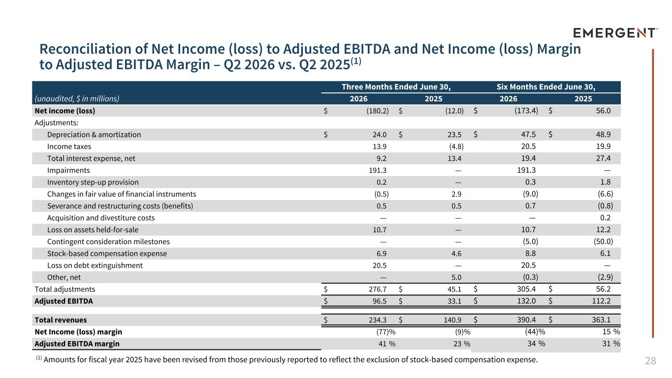
28 Reconciliation of Net Income (loss) to Adjusted EBITDA and Net Income (loss) Margin to Adjusted EBITDA Margin – Q2 2026 vs. Q2 2025(1) (unaudited, $ in millions) Three Months Ended June 30, Six Months Ended June 30, 2026 2025 2026 2025 Net income (loss) $ (180.2) $ (12.0) $ (173.4) $ 56.0 Adjustments: Depreciation & amortization $ 24.0 $ 23.5 $ 47.5 $ 48.9 Income taxes 13.9 (4.8) 20.5 19.9 Total interest expense, net 9.2 13.4 19.4 27.4 Impairments 191.3 — 191.3 — Inventory step-up provision 0.2 — 0.3 1.8 Changes in fair value of financial instruments (0.5) 2.9 (9.0) (6.6) Severance and restructuring costs (benefits) 0.5 0.5 0.7 (0.8) Acquisition and divestiture costs — — — 0.2 Loss on assets held-for-sale 10.7 — 10.7 12.2 Contingent consideration milestones — — (5.0) (50.0) Stock-based compensation expense 6.9 4.6 8.8 6.1 Loss on debt extinguishment 20.5 — 20.5 — Other, net — 5.0 (0.3) (2.9) Total adjustments $ 276.7 $ 45.1 $ 305.4 $ 56.2 Adjusted EBITDA $ 96.5 $ 33.1 $ 132.0 $ 112.2 Total revenues $ 234.3 $ 140.9 $ 390.4 $ 363.1 Net Income (loss) margin (77) % (9) % (44) % 15 % Adjusted EBITDA margin 41 % 23 % 34 % 31 % (1) Amounts for fiscal year 2025 have been revised from those previously reported to reflect the exclusion of stock-based compensation expense.

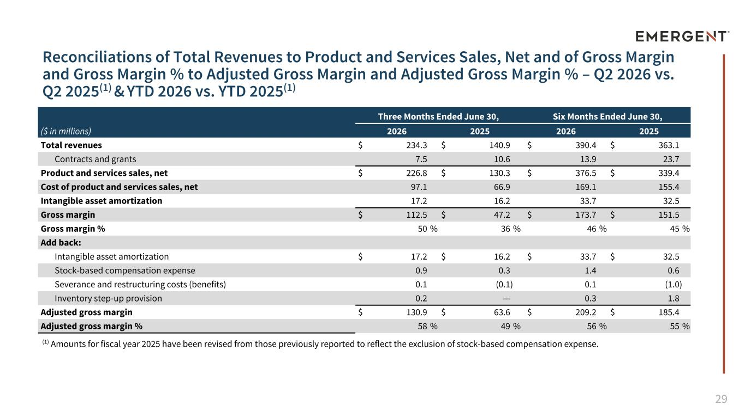
29 Reconciliations of Total Revenues to Product and Services Sales, Net and of Gross Margin and Gross Margin % to Adjusted Gross Margin and Adjusted Gross Margin % – Q2 2026 vs. Q2 2025(1) & YTD 2026 vs. YTD 2025(1) APPENDIX Three Months Ended June 30, Six Months Ended June 30, ($ in millions) 2026 2025 2026 2025 Total revenues $ 234.3 $ 140.9 $ 390.4 $ 363.1 Contracts and grants 7.5 10.6 13.9 23.7 Product and services sales, net $ 226.8 $ 130.3 $ 376.5 $ 339.4 Cost of product and services sales, net 97.1 66.9 169.1 155.4 Intangible asset amortization 17.2 16.2 33.7 32.5 Gross margin $ 112.5 $ 47.2 $ 173.7 $ 151.5 Gross margin % 50 % 36 % 46 % 45 % Add back: Intangible asset amortization $ 17.2 $ 16.2 $ 33.7 $ 32.5 Stock-based compensation expense 0.9 0.3 1.4 0.6 Severance and restructuring costs (benefits) 0.1 (0.1) 0.1 (1.0) Inventory step-up provision 0.2 — 0.3 1.8 Adjusted gross margin $ 130.9 $ 63.6 $ 209.2 $ 185.4 Adjusted gross margin % 58 % 49 % 56 % 55 % (1) Amounts for fiscal year 2025 have been revised from those previously reported to reflect the exclusion of stock-based compensation expense.

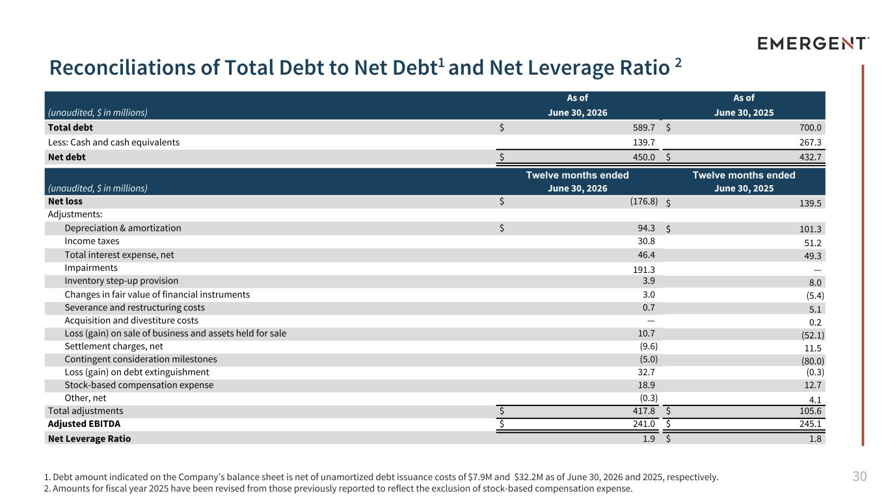
30 Reconciliations of Total Debt to Net Debt1 and Net Leverage Ratio 2 (unaudited, $ in millions) As of As of June 30, 2026 June 30, 2025 Total debt $ 589.7 $ 700.0 Less: Cash and cash equivalents 139.7 267.3 Net debt $ 450.0 $ 432.7 Twelve months ended Twelve months ended (unaudited, $ in millions) June 30, 2026 June 30, 2025 Net loss $ (176.8) $ 139.5 Adjustments: Depreciation & amortization $ 94.3 $ 101.3 Income taxes 30.8 51.2 Total interest expense, net 46.4 49.3 Impairments 191.3 — Inventory step-up provision 3.9 8.0 Changes in fair value of financial instruments 3.0 (5.4) Severance and restructuring costs 0.7 5.1 Acquisition and divestiture costs — 0.2 Loss (gain) on sale of business and assets held for sale 10.7 (52.1) Settlement charges, net (9.6) 11.5 Contingent consideration milestones (5.0) (80.0) Loss (gain) on debt extinguishment 32.7 (0.3) Stock-based compensation expense 18.9 12.7 Other, net (0.3) 4.1 Total adjustments $ 417.8 $ 105.6 Adjusted EBITDA $ 241.0 $ 245.1 Net Leverage Ratio 1.9 $ 1.8 1. Debt amount indicated on the Company’s balance sheet is net of unamortized debt issuance costs of $7.9M and $32.2M as of June 30, 2026 and 2025, respectively. 2. Amounts for fiscal year 2025 have been revised from those previously reported to reflect the exclusion of stock-based compensation expense.

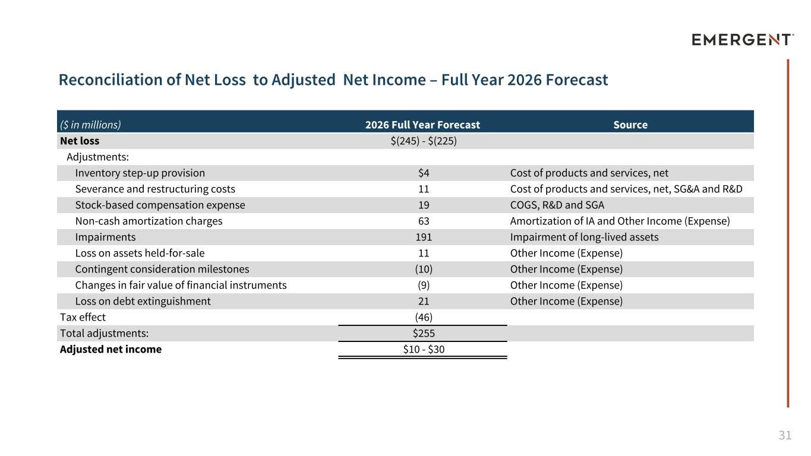
31 Reconciliation of Net Loss to Adjusted Net Income – Full Year 2026 Forecast ($ in millions) 2026 Full Year Forecast Source Net loss $(245) - $(225) Adjustments: Inventory step-up provision $4 Cost of products and services, net Severance and restructuring costs 11 Cost of products and services, net, SG&A and R&D Stock-based compensation expense 19 COGS, R&D and SGA Non-cash amortization charges 63 Amortization of IA and Other Income (Expense) Impairments 191 Impairment of long-lived assets Loss on assets held-for-sale 11 Other Income (Expense) Contingent consideration milestones (10) Other Income (Expense) Changes in fair value of financial instruments (9) Other Income (Expense) Loss on debt extinguishment 21 Other Income (Expense) Tax effect (46) Total adjustments: $255 Adjusted net income $10 - $30

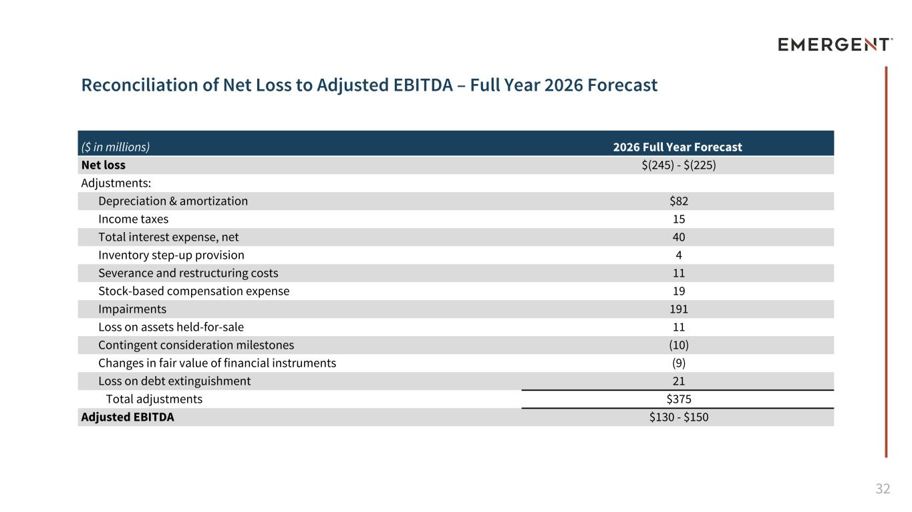
32 Reconciliation of Net Loss to Adjusted EBITDA – Full Year 2026 Forecast ($ in millions) 2026 Full Year Forecast Net loss $(245) - $(225) Adjustments: Depreciation & amortization $82 Income taxes 15 Total interest expense, net 40 Inventory step-up provision 4 Severance and restructuring costs 11 Stock-based compensation expense 19 Impairments 191 Loss on assets held-for-sale 11 Contingent consideration milestones (10) Changes in fair value of financial instruments (9) Loss on debt extinguishment 21 Total adjustments $375 Adjusted EBITDA $130 - $150

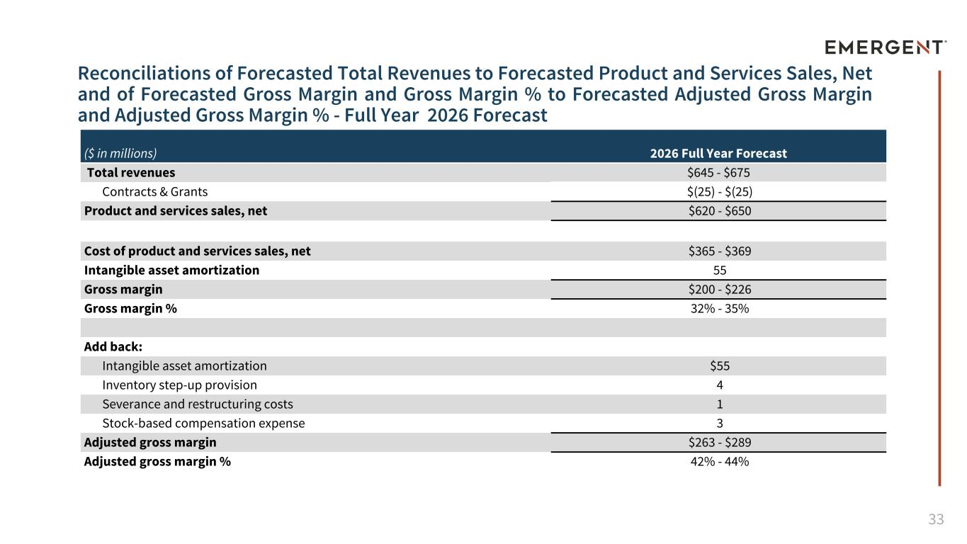
33 Reconciliations of Forecasted Total Revenues to Forecasted Product and Services Sales, Net and of Forecasted Gross Margin and Gross Margin % to Forecasted Adjusted Gross Margin and Adjusted Gross Margin % - Full Year 2026 Forecast ($ in millions) 2026 Full Year Forecast Total revenues $645 - $675 Contracts & Grants $(25) - $(25) Product and services sales, net $620 - $650 Cost of product and services sales, net $365 - $369 Intangible asset amortization 55 Gross margin $200 - $226 Gross margin % 32% - 35% Add back: Intangible asset amortization $55 Inventory step-up provision 4 Severance and restructuring costs 1 Stock-based compensation expense 3 Adjusted gross margin $263 - $289 Adjusted gross margin % 42% - 44%



